HEAVY VEHICLE NATIONAL LAW
Tasmania Higher Mass Limits Declaration 2016 (No.1)
Statutory Instrument Series:
Heavy Vehicle Higher Mass Limits Declaration
- Purpose

The purpose of this Declaration is to authorise the use of certain categories of heavy vehicles under higher mass limits on stated areas and routes in Tasmania.

- Authorising Provisions

This Declaration is made under section 12 of the Heavy Vehicle (Mass, Dimension and Loading) National Regulation (the National Regulation).

- Title

This Declaration may be cited as the Tasmania Higher Mass Limits Declaration 2016.

- Commencement

This Declaration commences on 1 December 2016.

- Expiry

This Declaration expires on 30 November 2021.

- Definitions

- In this Declaration -

Eligible vehicle means a HML heavy vehicle fitted with:
- an 8-tyred tandem axle group; or
- a 12-tyred tri-axle group.

- Application

This Declaration applies to eligible vehicles operating in Tasmania.

- Stated Areas and Routes

An eligible vehicle may use the routes set out in the Tasmanian Declared HML Route Network published by the Tasmania Department of State Growth.

Note: The Tasmania HML Network may be found at http://data.stategrowth.tas.gov.au/Networks/?mapName=HML

Dated: 25 November 2016
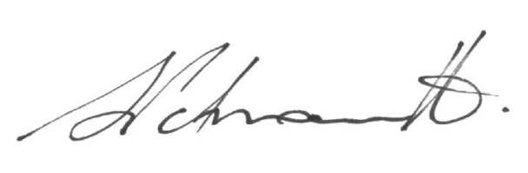

Sal Petroccitto
Chief Executive Officer
National Heavy Vehicle Regulator

