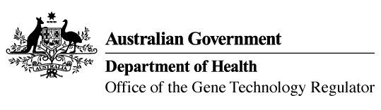
8 February 2017

Invitation to comment on a genetically modified (GM) wheat field trial
Australia’s gene technology regulatory system is designed to protect the health and safety of people and the environment by identifying risks posed by, or as a result of, gene technology and managing those risks.
The Gene Technology Regulator is currently assessing licence application DIR 151 from CSIRO. The application is for a field trial (limited and controlled release) of wheat genetically modified for disease resistance, drought tolerance, altered oil content and altered grain composition. The purpose of the field trial is to assess the agronomic characteristics of the GM wheat plants under field conditions.
The trial is proposed to take place at two sites of up to 1 hectare each, at Boorowa Experiment Station (NSW) and Ginninderra Experiment Station (ACT), from May 2017 to May 2022. The GM wheat would not be used for commercial human food or animal feed.
A consultation Risk Assessment and Risk Management Plan (RARMP) has been prepared, which concludes that the proposed release would pose negligible risk to human health and safety or to the environment. A range of draft licence conditions would limit the size, location and duration of the release, as well as restrict the spread and persistence of the GMOs and the introduced genetic material.
The Regulator welcomes written submissions in order to finalise the RARMP, which will then inform the decision on whether or not to issue the licence. The consultation RARMP and related documents can be obtained from the OGTR website under What’s New or by contacting the Office. Please quote application DIR 151 in any correspondence.
Submissions should be received by close of business on 22 March 2017.
Office of the Gene Technology Regulator, MDP 54, GPO BOX 9848 CANBERRA ACT 2601
Telephone: 1800 181 030 Facsimile: 02 6271 4202 E-mail: ogtr@health.gov.au
OGTR website www.ogtr.gov.au

