***Customs Act 1901***

**Notice under Subsection 15(2)(a)**

**Wharf Notice of Appointment (2598)**

I, William Ries, delegate of the Comptroller-General of Customs, under paragraph 15(2)(a) of the *Customs Act 1901:*

1. APPOINT as a wharf in the Port of Portland the area known as Lee Breakwater Wharf in the State of Victoria and
2. FIX the limits of that wharf within the red boundary line indicated in **Attachment A** to this notice.

This notice commences on 10 March 2017.

Dated 10 March 2017

Commander

Operational Strategies Branch

Border Management Division

Australian Border Force

Department of Immigration and Border Protection

**Attachment A**



**Lee Breakwater Wharf**

Department of Immigration and Border Protection

S15 of *Customs Act 1901* Wharf, Appointment (**No2598**)

LEGEND

Limits of the wharf appointed under s15(2) (a) of the *Customs Act 1901* 

Map scale - 1:5000 at A4

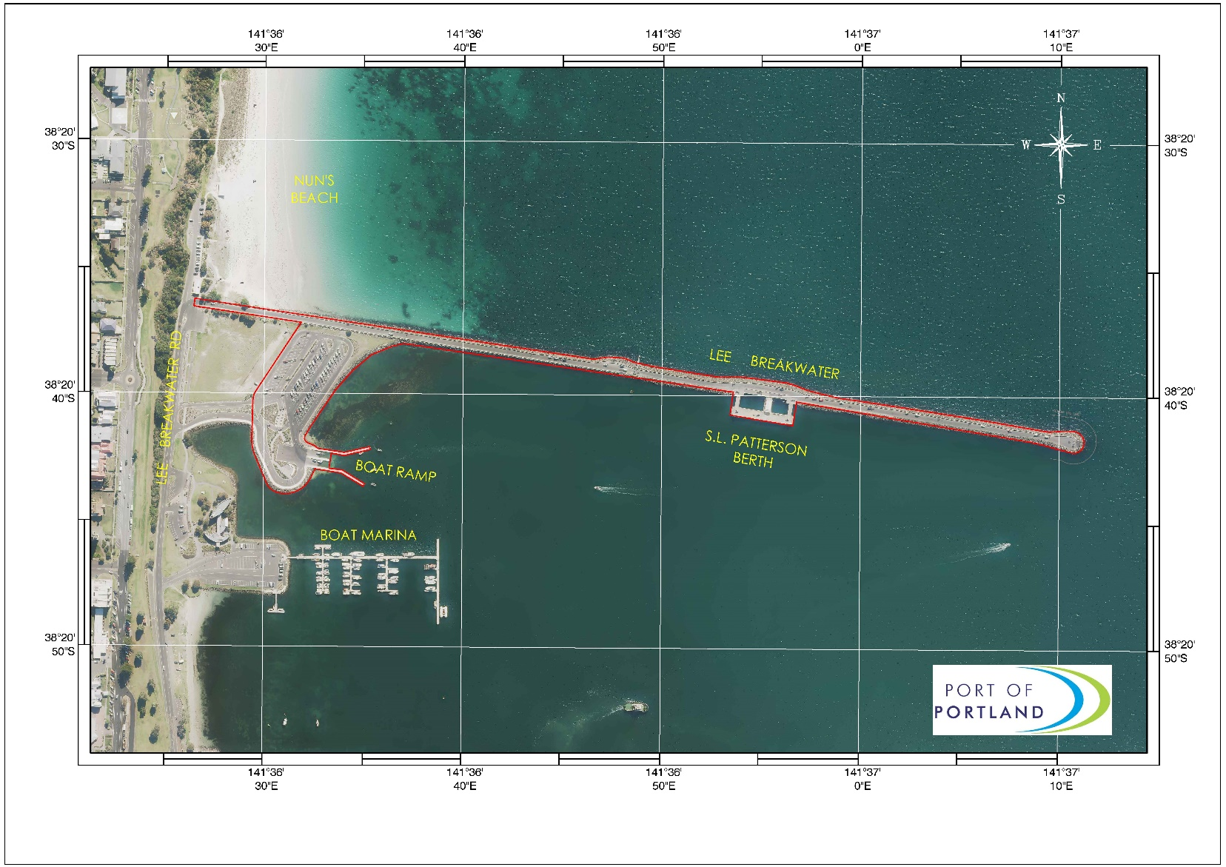

**Section 15(2)(a) of the *Customs Act 1901* Wharf Limits**

Lee Breakwater Wharf Prepared by: Richard Beal (Port of Portland) Date: 06/06/2016