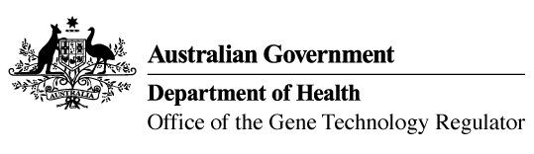
26 April 2017

Invitation to comment on a genetically modified (GM)

wheat and barley field trial
Australia’s gene technology regulatory system is designed to protect the health and safety of people and the environment by identifying risks posed by, or as a result of, gene technology and managing those risks.
The Gene Technology Regulator is currently assessing licence application DIR 152 from the University of Adelaide. The application is for a field trial (limited and controlled release) of wheat and barley genetically modified for yield enhancement and frost tolerance. The purpose of the field trial is to assess the agronomic characteristics of the GM wheat and barley plants under field conditions.
It is proposed that the trial will take place at up to five sites, with up to 3.75 hectares per growing season (across all sites) in South Australia, Western Australia and New South Wales, between July 2017 and January 2021. The GM wheat and barley would not be used for commercial human food or animal feed.
A consultation Risk Assessment and Risk Management Plan (RARMP) has been prepared, which concludes that the proposed release would pose negligible risk to human health and safety or to the environment. A range of draft licence conditions would limit the size, location and duration of the release, as well as restrict the spread and persistence of the GMOs and the introduced genetic material.
The Regulator welcomes written submissions in order to finalise the RARMP, which will then inform the decision on whether or not to issue the licence. The consultation RARMP and related documents can be obtained from the OGTR website under What’s New or by contacting the Office. Please quote application DIR 152 in any correspondence.
Submissions should be received by close of business on 07 June 2017.
Office of the Gene Technology Regulator, MDP 54, GPO BOX 9848 CANBERRA ACT 2601
Telephone: 1800 181 030 Facsimile: 02 6271 4202 E-mail: ogtr@health.gov.au
OGTR website www.ogtr.gov.au

