|  |
| --- |
| NTC-13140 |
|  |

***Aviation Transport Security Act 2004***

**NOTICE OF DECLARATION OF SECURITY CONTROLLED AIRPORT AND AIRSIDE AREA – TOWNSVILLE AIRPORT**

I, **ROBERT PUGSLEY**, Director, Transport Security Operations, Office of Transport Security:

**REVOKE**, under subsection 28(2) of the *Aviation Transport Security Act 2004* (the Act), Notice A04960 which declared Townsville Airport as a security controlled airport as published in the *Gazette (No. GN 18, 8 May 2013)*;

**DECLARE**, under subsection 28(2) of the Act, that Townsville Airport is a security controlled airport, the boundaries of Townsville Airport are shown on the attached map which forms part of this notice; and

**ESTABLISH,** in accordance with section 29 of the Act, an airside area for Townsville Airport being that area indicated as the airside area on the attached map.

This Notice commences upon publication in the *Gazette*.

Date: 2 May 2017

Robert Pugsley

Delegate of the Secretary of the

Department of Infrastructure and Regional Development

Note:

1. *Gazette* means the *Commonwealth of Australia Gazette*
2. This Notice remains in force until otherwise revoked in writing and upon subsequent publication in the *Gazette*

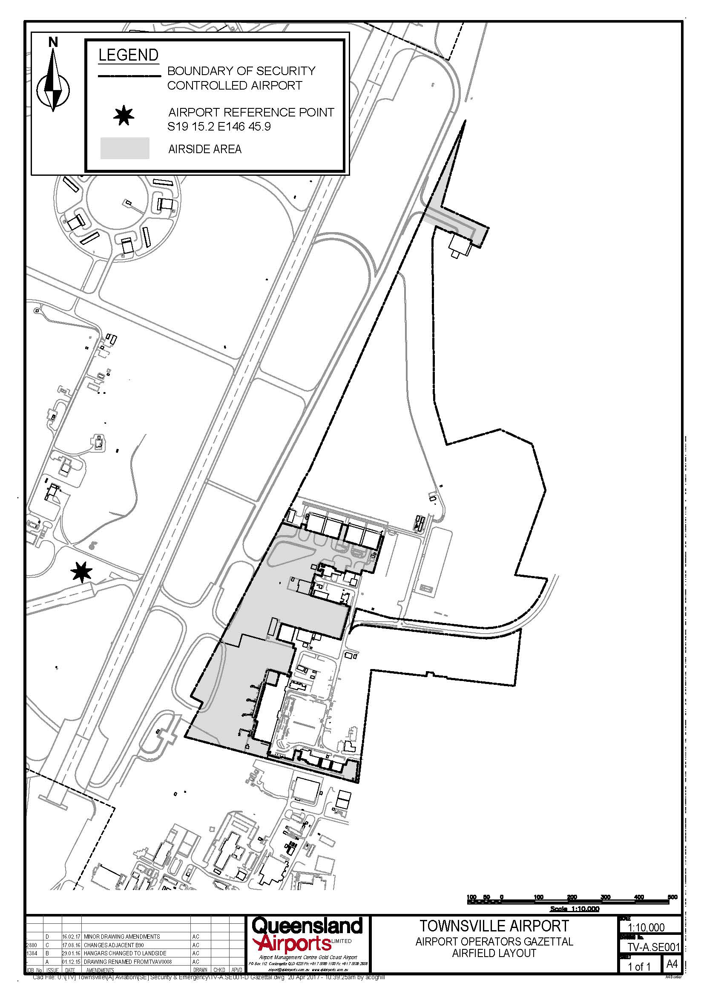

This map shows the boundaries of the security controlled airport and airside area for the purpose of the *Aviation Transport Security Act 2004* and the Aviation Transport Security Regulations 2005 only. The map should not be used for air navigation purposes. Further information can be obtained from the Department of Infrastructure and Regional Development, Office of Transport Security (OTS), GPO Box 594, Canberra ACT 2601, or phone the Transport Security Coordination Team on 1300 791 581.