***Aboriginal and Torres Strait Islander Heritage Protection Act 1984* (Cth)**

**Notice of an application for the protection of Butterfly Cave, West Wallsend**

**Invitation to make representations**

I, Susan McIntyre-Tamwoy, hereby give notice as follows:

The Minister for the Environment and Energy, the Hon Josh Frydenberg MP, being the Minister responsible for the *Aboriginal and Torres Strait Islander Heritage Protection Act 1984* (Cth)(**the Act**), has received an application made under section 10 of the Act seeking to protect Butterfly Cave, West Wallsend, in New South Wales, and nominated me to provide a report to him under section 10(1)(c) of the Act.

### The applicants

The application is made by the New South Wales Aboriginal Land Council, on behalf of the Awabakal Local Aboriginal Land Council.

### The purpose of the application

The application seeks the preservation or protection of the area specified in the application, and shown at Figure 1 below, from injury or desecration. Section 10 of the Act enables the Minister to decide whether to make a declaration to preserve and protect the specified area, if the Minister is satisfied that the area is a significant Aboriginal area and is under threat of injury or desecration. In the Act, the term ‘significant Aboriginal area’ refers to an area that is of particular significance to Aboriginal people in accordance with Aboriginal tradition. Section 3 of the Act provides definitions of ‘significant Aboriginal area’ and other relevant terms including ‘Aboriginal tradition’ and ‘injured or desecrated’. The area specified for protection, the claimed significance of the area, and the claimed nature of the threat of injury or desecration are set out below.

### Matters the report is required to deal with

The Minister will consider my report under section 10 of the Act in relation to the area specified for protection before deciding whether to make a declaration under section 10 of the Act. Under section 10(4) of the Act, the report is required to deal with the following matters:

1. the particular significance of the area to Aboriginals;
2. the nature and extent of the threat of injury to, or desecration of, the area;
3. the extent of the area that should be protected;
4. the prohibitions and restrictions to be made with respect to the area;
5. the effects the making of a declaration may have on the proprietary or pecuniary interests of persons other than the Aboriginal or Aboriginals making the application or on whose behalf the application is made;
6. the duration of any declaration; and
7. the extent to which the area is or may be protected by or under a law of New South Wales, and the effectiveness of any remedies available under any such law.

### The area sought to be protected (the 'specified area')

1. The applicant specifies the area for which protection is sought as being located in West Wallsend, New South Wales and comprising Lots 5/DP1180029 and 6/DP1180029.

The area includes Butterfly Cave and a minimum radius of 100 m around the cave, including the following features:

* aquifers,
* stone arrangement,
* traditional journey path,
* main creek,
* feeder creek, and
* food source areas.

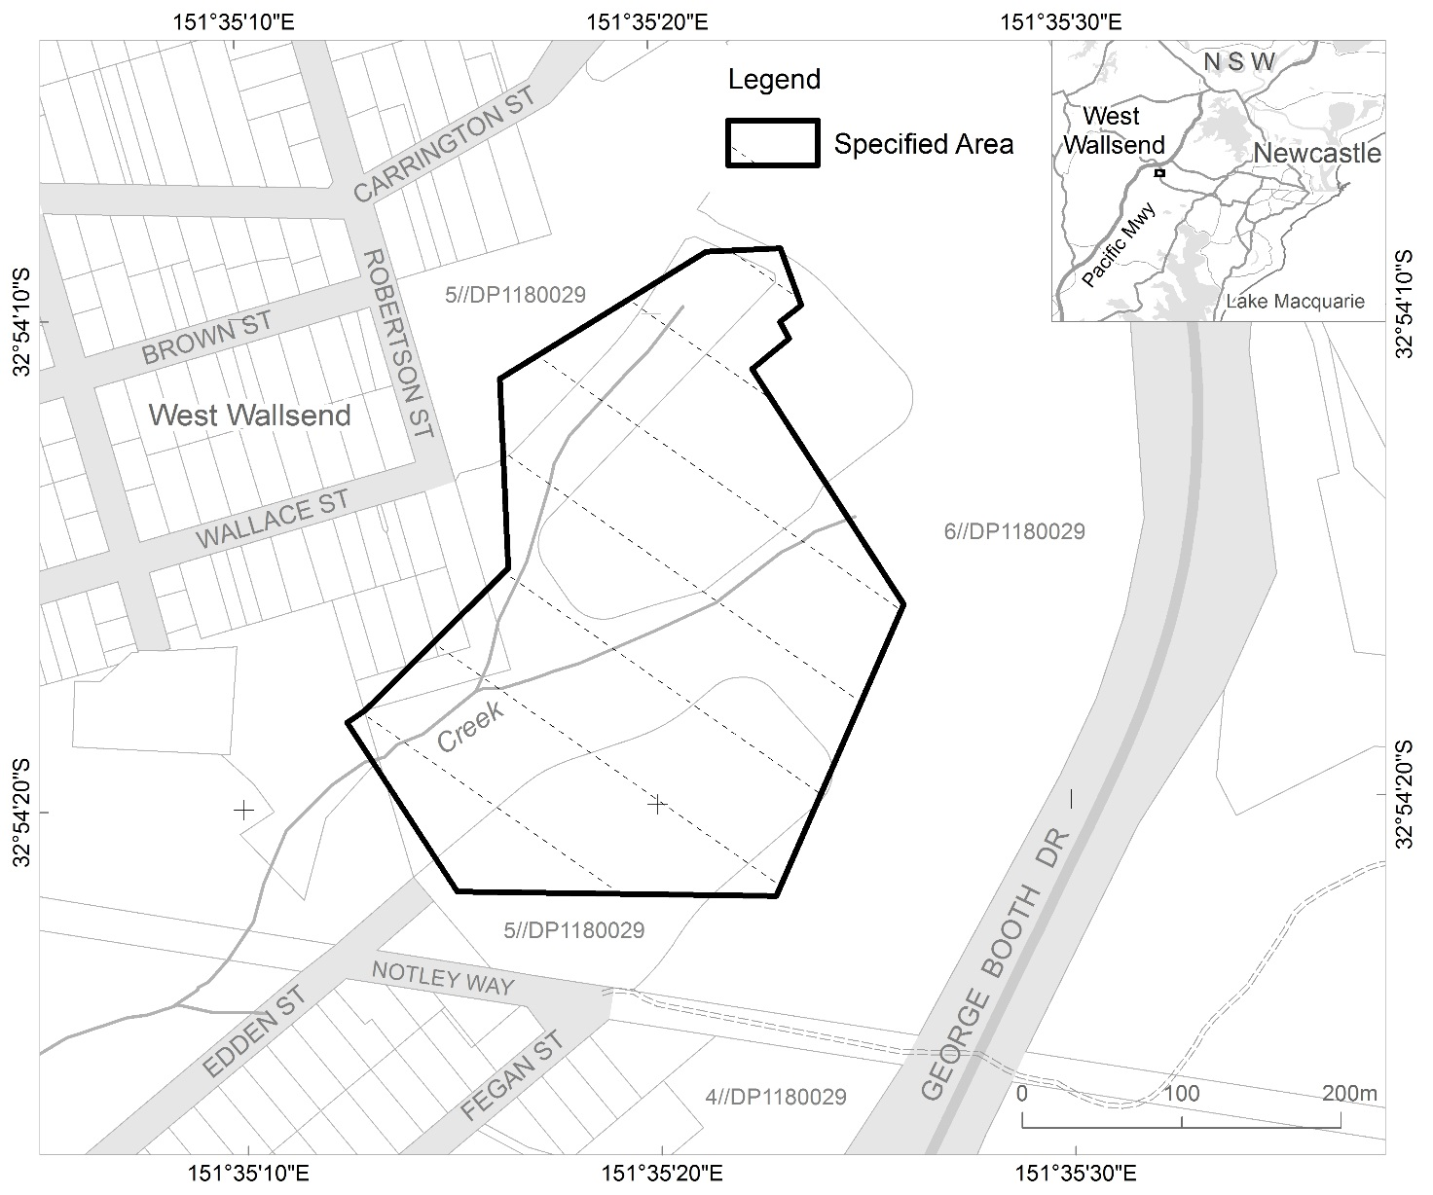

Figure 1 Map showing the specified area known as Butterfly Cave, West Wallsend, New South Wales

### Claimed nature of particular significance

The application indicates that the particular significance of the specified area arises because:

* Butterfly Cave is a site of sacred women’s business.
* The seclusion of the cave is also significant as it provides privacy for women’s traditional and sacred activities.
* Along with wildlife, the native vegetation within the specified area has a practical, aesthetic and spiritual value and provides a source of food and medicine.
* The specified area continues to be used as a place to learn about traditional practices such as collecting bush foods and natural medicines.
* It is a place for cultural and spiritual connection, and education of Aboriginal and non-Aboriginal women and girls. This is supported through the NSW Department of Education’s Sista Speak Program.

### Claimed threat of injury or desecration

The application indicates that the potential injury or desecration is associated with the proposed subdivision and residential development of Appletree Grove Estate – Stage 7 and Stage 9. This includes the proposed construction of a road less than 10 metres, and dwellings and associated services less than 20 metres from Butterfly Cave. The application indicates that, as the specified area is significant as a food source area, the removal of native vegetation and diversion of water courses irrevocably affects the traditional use of the area. Additionally, the application indicates that since the proposed development will occur approximately 10 metres away from Butterfly Cave, it will lose its significance as a private and secluded place for Aboriginal women. The application further claims that the use of heavy machinery and construction tools is a source of vibration that may cause irreversible physical damage to Butterfly Cave. Other threats of injury or desecration outlined in the application include reduced access to Butterfly Cave for Aboriginal women, a loss of the traditional access path, and the risk of vandalism associated with increased human activity in the area.

### Invitation to make representations

Interested persons are invited to make representations on this matter to:

Susan McIntyre-Tamwoy

Associate Director

Extent Heritage Pty Ltd  
Level 3, 73 Union St  
Pyrmont NSW 2009

Telephone: 0428 673 112

Email: [submissions@extent.com.au](mailto:submissions@extent.com.au)

Representations must be made in writing by close of business by 12 July 2017 or within such further period as I may allow. **You should not send your representations directly to the Minister.**

If you wish to claim confidentiality over any part of your representation, please identify why you are claiming confidentiality and how you want confidentiality to apply. All representations, whether or not they are provided in confidence, will be provided to the Minister for the Environment and Energy, and the Department of the Environment and Energy, along with the section 10 report. Representations, even those subject to confidentiality, may be disclosed where it is authorised or required by law, to meet procedural fairness requirements, and in response to a request by a House or Committee of the Parliament of the Commonwealth.