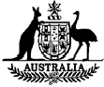

**GOVERNMENT NOTICES**

**Commonwealth of Australia**

Published by the Commonwealth of Australia

**Gazette**



**Government House CANBERRA ACT 2600**

**22 August 2017**

# VICTORIA CROSS FOR AUSTRALIA DETERMINATION 2017

I, **SIR PETER COSGROVE,** Governor-General of the Commonwealth of Australia, acting in pursuance of regulations 9 and 10 of the *Victoria Cross Regulations,* revoke the *Victoria Cross Determination* made on the eleventh day of November 1991, and hereby determine as follows:

# Medal Design

1. The Victoria Cross is a bronze cross with each axis measuring 35 millimetres. The arms of the cross have raised edges. The obverse bears a Crowned Lion standing on the Royal Crown with the words 'FOR VALOUR' inscribed on a semi-circular scroll below the Crown. The reverse bears raised edges on the arms of the cross and the date of the act for which the Cross is awarded is engraved within a circle in the centre.

# Medal Ribbon

1. The Victoria Cross is suspended from a crimson ribbon 38.5 millimetres wide.

# Medal Miniature

1. The miniature of the Victoria Cross is a half-size replica of the Cross suspended from a crimson miniature ribbon 16 millimetres wide.

# Ribbon Bar

1. The ribbon bar of the Victoria Cross consists of a strip of full-size ribbon, 41 millimetres wide and 10 millimetres high, and is worn with an emblem which is a representation of the Cross, each axis measuring 9 millimetres.

# Lapel Badge

1. The lapel badge of the Victoria Cross is a replica of the Cross, with each axis measuring 10 millimetres.

# Further Awards

1. Second and subsequent awards are recognised by the presentation of a bar, the dimensions of which are 38.5 millimetres wide and 6 millimetres high, worn attached to the ribbon of the full-size Cross. A half-size replica of the bar is worn attached to the ribbon of the miniature Cross. An additional emblem is worn on the ribbon bar for each further award.

# Wearing

1. The Victoria Cross is worn on the left breast whenever full-size orders, decorations and medals are worn. The miniature Cross is worn whenever miniatures of orders, decorations and medals are worn. The ribbon bar may be worn at any time with service dress. The lapel badge may be worn at any time with civilian dress.

# Order of Wear

1. The Victoria Cross is worn in accordance with the *Order of Wearing Australian Honours and Awards* as approved by The Sovereign.

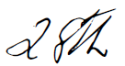

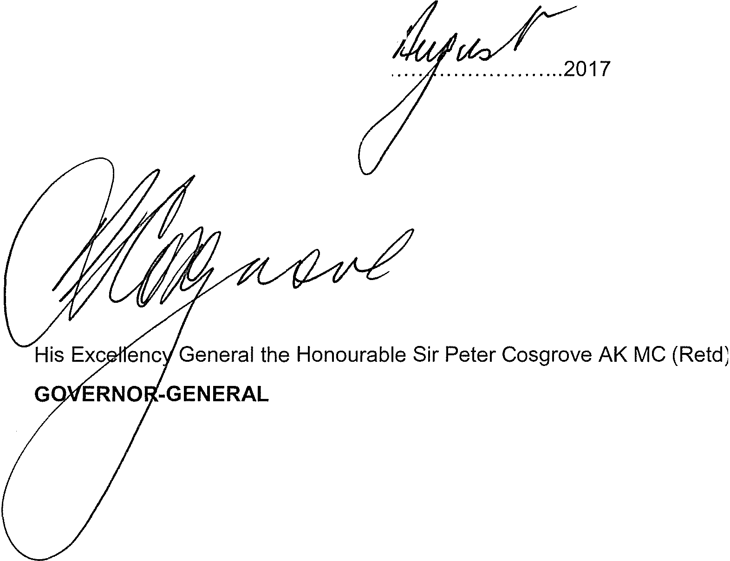

Dated this........................day of.........

*df/l EDWARDS Grant per ELDRIDGE Heather - QB17 Investiture - new Entree Cards - address confirmation and age of guest - reply*

