Government House

CANBERRA ACT 2600

19 September 2017

It is notified for general information that the Governor-General has approved the following award.

COMMENDATION FOR GALLANTRY

Flying Officer Harold Bertie CHATFIELD
Victoria
For acts of gallantry in action as a member of Number 615 Squadron,
Royal Air Force, during the air war in Burma from December 1943 to June 1944.

By His Excellency’s Command

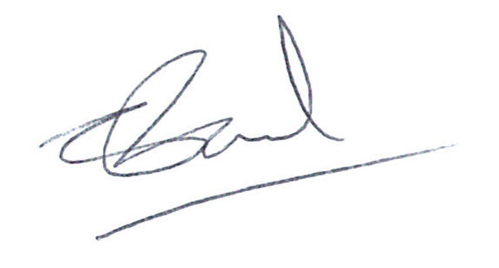

Chandy Paul
Acting Official Secretary to the Governor-General
COMMENDATION FOR GALLANTRY

Flying Officer Harold Bertie CHATFIELD, Victoria

For acts of gallantry in action as a member of Number 615 Squadron, Royal Air Force, during the air war in Burma from December 1943 to June 1944.

Flight Sergeant Chatfield gallantly executed his role as wingman in exemplary fashion in attacking large formations of Japanese aircraft during the period December 1943 to June 1944, specifically, his actions of 26 December 1943 when, with only one other aircraft, he successfully prosecuted a number of attacks on the numerically superior Japanese force.

