Government House
CANBERRA ACT 2600

22 September 2017

ORDER OF AUSTRALIA

It is notified for general information that the Governor-General has cancelled the award of the Medal of the Order of Australia in the General Division made to:

Mr Paul Richard Wilson

By His Excellency’s Command

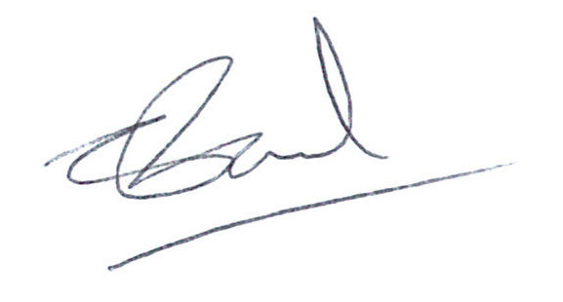

Chandy Paul

Acting Secretary of the Order of Australia

