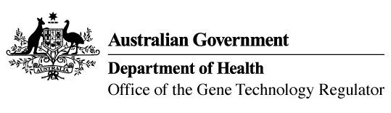

5 October 2017

Invitation to comment on commercial release of genetically modified (GM) canola
Australia’s gene technology regulatory system is designed to protect the health and safety of people and the environment by identifying risks posed by, or as a result of, gene technology and managing those risks.
The Gene Technology Regulator is currently assessing licence application DIR 155 from Nuseed Pty Ltd for a commercial release of DHA canola. This GM canola has been modified for altered omega-3 oil content in the seed.
Subject to any State government restrictions imposed for marketing reasons, the proposed commercial release of the GM canola would be Australia-wide. Products from the GM canola plants would be used in the same way as those from non-GM and other commercially approved GM canola.
A consultation Risk Assessment and Risk Management Plan (RARMP) has been prepared, which concludes that the proposed release would pose negligible risk to human health and safety or to the environment. Draft licence conditions are proposed to ensure there is ongoing oversight of the release.
The Regulator welcomes written submissions in order to finalise the RARMP, which will then inform the decision on whether or not to issue a licence. The consultation RARMP and related documents can be obtained from the OGTR website under ‘What’s New’ or by contacting the Office. Please quote application number DIR 155 in any correspondence.
Submissions should be received by close of business on 30 November 2017.
Office of the Gene Technology Regulator, MDP 54, GPO Box 9848 Canberra ACT 2601
Telephone: 1800 181 030 Facsimile: 02 6271 4202 E-mail: ogtr@health.gov.au
Website: http://www.ogtr.gov.au

