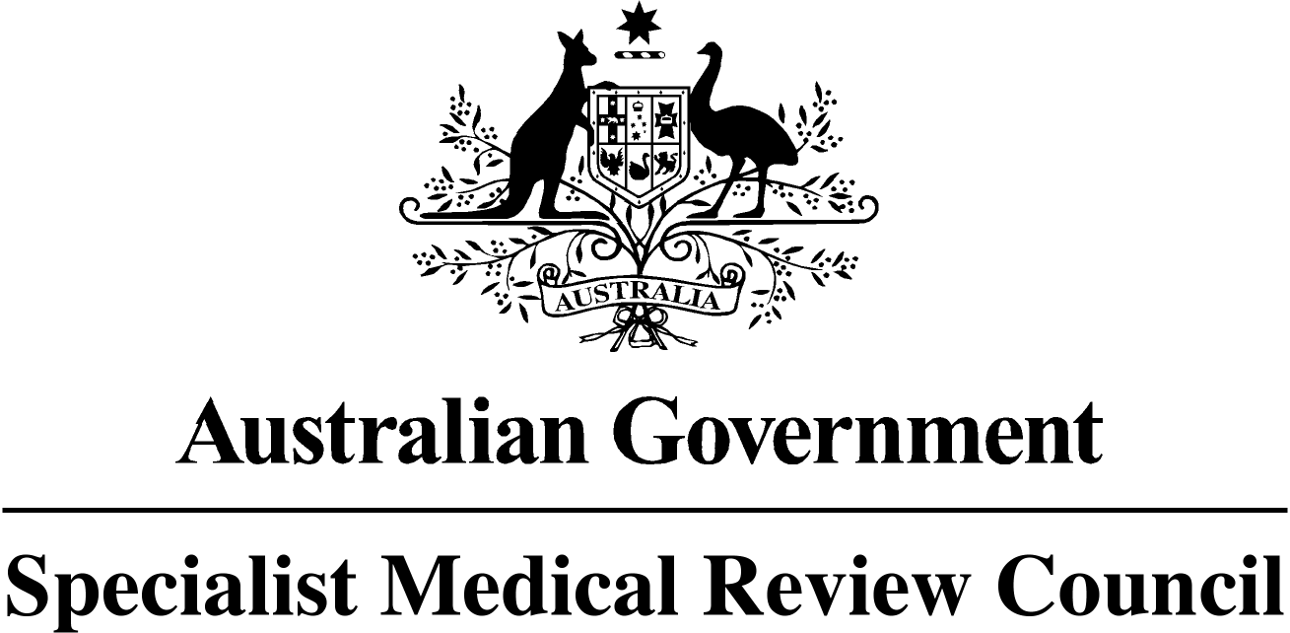

**SPECIALIST MEDICAL REVIEW COUNCIL**

***Veterans’ Entitlements Act 1986***

**Section 196ZB**

**NOTIFICATION OF INTENTION TO CARRY OUT A REVIEW**

The Specialist Medical Review Council (the Council) has been asked under section 196Y of the *Veterans’ Entitlements Act 1986* (the Act) to review the decision of the Repatriation Medical Authority (the RMA) not to determine Statement of Principles in respect of “Chemically acquired brain injury caused by mefloquine, tafenoquine or primaquine”. The Council gives notice under section 196ZB of the Act that it intends to carry out a review under section 196W of the Act of all the information available to the RMA when it decided not to determine Statements of Principles in respect of “**chemically acquired brain injury caused by mefloquine, tafenoquine or primaquine”.**

The Council is giving notice of this review so that the following eligible persons and organisations:

1. are aware that the application for review have been made, and
2. may, should they so wish, make written submissions to the Council:

* The Repatriation Commission
* The Military Rehabilitation and Compensation Commission
* A person eligible to make a claim for a pension under Part II or IV of the Act
* A person eligible to make a claim for compensation under section 319 of the Military Rehabilitation and Compensation Act 2004; and
* An organisation representing veterans, Australian Mariners, members of the Forces, members of Peacekeeping Forces or their dependants.

Written submissions must be received by **9 February 2018**.

The Council will hold its first meeting for the purposes of this review after 9 February 2018. The location, date and time of the meeting for the hearing of oral submissions complementing written submissions will be advised to the persons/organisations that have asked for the review under section 196Y of the Act and those persons and organisations that make written submissions.

For advice on the preparation of written submissions contact the Council Secretariat on 07 3223 8840, or via the website [www.smrc.gov.au](http://www.smrc.gov.au). Submissions should be lodged with the Council Secretariat, PO Box 965, Brisbane, QLD 4001.

Charles Guest

Convener