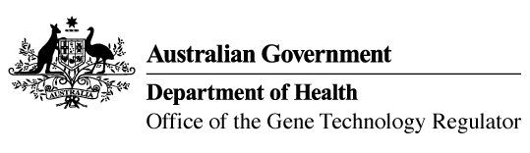
29 January 2018

Invitation to comment on a genetically modified (GM) buffalo grass field trial
Australia’s gene technology regulatory system is designed to protect the health and safety of people and the environment by identifying risks posed by, or as a result of, gene technology and managing those risks.
The Gene Technology Regulator is currently assessing licence application DIR 156 from the Royal Melbourne Institute of Technology (RMIT) University in Victoria. The application is for a field trial (limited and controlled release) of buffalo grass genetically modified for herbicide tolerance and dwarf growth habit. The purpose of the field trial is to assess the agronomic characteristics of the GM buffalo grass plants under field conditions.
The trial is proposed to take place between April 2018 and April 2019 in Bundoora (Victoria) on a maximum area of 200 m². GM buffalo grass grown in this field trial would not be used as animal feed.
A consultation Risk Assessment and Risk Management Plan (RARMP) has been prepared, which concludes that the proposed release would pose negligible risk to human health and safety or to the environment. A range of draft licence conditions would limit the size, location and duration of the release, as well as restrict the spread and persistence of the GMOs and the introduced genetic material.
The Regulator welcomes written submissions in order to finalise the RARMP, which will then inform the decision on whether or not to issue the licence. The consultation RARMP and related documents can be obtained from the OGTR website under What’s New or by contacting the Office. Please quote application DIR 156 in any correspondence.
Submissions should be received by close of business on 1 March 2018.
Office of the Gene Technology Regulator, MDP 54, GPO BOX 9848 CANBERRA ACT 2601
Telephone: 1800 181 030 E-mail: ogtr@health.gov.au
OGTR website www.ogtr.gov.au

