***Aboriginal and Torres Strait Islander Heritage Protection Act 1984 (Cth)***

**Notice of an application for the protection of significant traditional areas located within the proposed Shenhua Watermark Coal Mine, Breeza, New South Wales**

**Invitation to make representations**

I, Susan Phillips, hereby give notice as follows:

The Minister for the Environment and Energy, responsible for the *Aboriginal and Torres Strait Islander Heritage Protection Act 1984* (Cth)(the **Act**), has received an application made under section 10 of the Act. The application is seeking to protect traditional areas located within the proposed Shenhua Watermark Coal Mine, Breeza, New South Wales, and appointed me to provide a report to him under section 10(1)(c) of the Act.

### The Applicants

The application is made by Andrew Beatty, of Beatty Legal Pty Ltd, on behalf of the Gomeroi Traditional Custodians.

### The purpose of the application

The application seeks the preservation or protection of the area specified in the application, and shown at Figure 1 below, from injury or desecration. Section 10 of the Act enables the Minister to decide whether to make a declaration to preserve and protect the specified area, if the Minister is satisfied that the area is a significant Aboriginal area and is under threat of injury or desecration. In the Act, the term ‘significant Aboriginal area’ refers to an area that is of particular significance to Aboriginal people in accordance with Aboriginal tradition. Section 3 of the Act provides definitions of ‘significant Aboriginal area’ and other relevant terms including ‘Aboriginal tradition’ and ‘injured or desecrated’. The area specified for protection, the claimed significance of the area, and the claimed nature of the threat of injury or desecration are set out below.

### Matters the report is required to deal with

The Minister will consider my report under section 10 of the Act in relation to the area specified for protection before deciding whether to make a declaration. Under section 10(4) of the Act, the report is required to deal with the following matters:

1. the particular significance of the area to Aboriginal people;
2. the nature and extent of the threat of injury to, or desecration of the area;
3. the extent of the area that should be protected;
4. the prohibitions and restrictions to be made with respect to the area;
5. the effects the making of a declaration may have on the proprietary or pecuniary interests of persons other than the applicants on whose behalf the application is made;
6. the duration of any declaration;
7. the extent to which the area is or may be protected by or under a law of the State of New South Wales, and the effectiveness of any remedies available under any such law; and
8. such other matters (if any) as are prescribed.

**The area sought to be protected (the 'specified area')**

The applicant specifies eight areas for which protection is sought as traditional areas located within and near the proposed Shenhua Watermark Coal Mine, Breeza, New South Wales. These include:

* Watermark Mountain (the entire mountain)
* Two grinding groove complexes
* One culturally significant gully area
* One culturally significant river area
* One culturally significant swamp
* Three culturally modified trees

In addition, the applicants have requested that a defence, protective and hunting area (travelling and viewing corridor) and a ceremonial travelling and viewing corridor from the summit of Watermark Mountain looking towards the culturally significant areas identified above, must not be impacted by overburden from the mine works or other significant landscape changes.

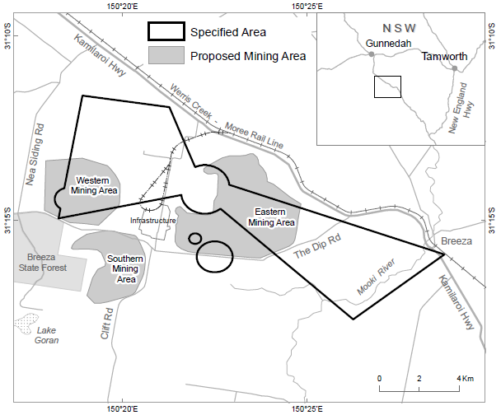

Figure 1: Map showing the specified area near Watermark Mountain, New South Wales.

**Claimed nature of particular significance**

The application indicates that the particular significance of the specified area arises predominately from its significance as (summarised version of the Applicants’ claims):

* The areas are part of the Applicants’ traditional homelands (Country) and senior Elders and traditional owners strongly identify their connection to Country with the cultural practices and memories relating to the areas. There is a deep cultural, social, environmental, spiritual and economic connection of the traditional owners, the Gomeroi (also identified as Kamilaroi) and other Nations to the lands and waters within and beyond the project area.
* A connection with the Dreamtime and a connection to the past. The interaction between connection to Country and cultural identity is highly important as traces and memories of the past contribute to maintaining distinctive Gomeroi and Aboriginal culture and spirituality, and cultural interaction with the landscape.
* The area contains lore and traditions associated with guarding and guiding people through the area and will remove the footprint of ancestral songlines that keep the meaning of this lore and tradition.
* The area plays a broader cultural role in ceremonial, spiritual and religious songlines used by many south-eastern Indigenous Australian communities, including the Gomeroi. The area is a ‘cultural junction area’ where gathering, ceremony, trade and defence of country take place.
* The archaeological sites and objects throughout the area show tangible evidence of culturally significant places and objects contributing to the cultural meaning and understanding for Aboriginal and non-Aboriginal people. These objects and their changing uses over time show an evolutionary, historical and cultural connection to the project area.
* The areas and the general region have a history of continued camping and social, cultural and spiritual importance and connection, while also having a number of relationships to dispossession and violence, including against women, children and families.
* There are continued historic and contemporary cultural practices relating to the areas, including hunting as well as gathering of medicinal plants and vegetation for bush tucker purposes and gathering of materials for cultural arts. Grinding grooves contained within the specified area have been attributed to the preparation of both food sources and stone artefacts.
* The area has rare, intact grinding groove sites, burial cairns, burial trees, markers and pathway indicators and ceremonial places containing the remains of ancestral family members and Elders.
* The general region has a history of Gomeroi (also identified and referenced as Kamilaroi) resistance and organised frontier warfare.
* The general region has a history of massacres against Aboriginal people which requires acknowledgement, reconciliation and healing.
* The places and culturally sensitive and significant objects within the cultural landscape are particularly important to the Gomeroi, especially to the values for Gomeroi men.
* There is evidence of multiple use, and ingenuity in the use, of resources for cultural purposes.
* The project area houses numerous multi-complex burial places, showing rare examples of differing practices and traditions used under local law and remain part of traditional teachings today.
* Ceremonial or place markers that in the area denote ceremonial usage, where certain aspects of culture are taught (teleteglyphs), or places, primarily as indications of burial sites (taphoglyphs).
* Trees within the areas have cultural value because of their historic utility. For example, trees were used for water extraction and as food larders.

**Claimed threat of injury or desecration**

The application indicates that the potential injury or desecration is attributed to the development of the Watermark Coal Mine near Breeza, New South Wales, by Shenhua Watermark Pty Ltd. The application claims that the large scale open cut coal mining project will irreversibly desecrate or destroy the specified areas.

**Invitation to make representations**

Interested persons are invited to make representations on this matter to:

Susan Phillips  
Barrister   
13th Floor, St James Hall   
169 Phillip Street  
PYRMONT NSW 2000

Ph: 02 9335 3063  
Fax: 02 9237 0895  
Email: [phillips@stjames.net.au](mailto:phillips@stjames.net.au)

Representations must be made in writing by close of business 06 April 2018 or within such further period as may be allowed. **You should not send your representations directly to the Minister.**

If you wish to claim confidentiality over any part of your representation, please identify why you are claiming confidentiality and how you want confidentiality to apply. All representations, whether or not they are provided in confidence, will be provided to the Minister for the Environment and Energy, and the Department of the Environment and Energy, along with the section 10 report. Representations, even those subject to confidentiality, may be disclosed where it is authorised or required by law, to meet procedural fairness requirements, and in response to a request by a House or Committee of the Parliament of the Commonwealth.