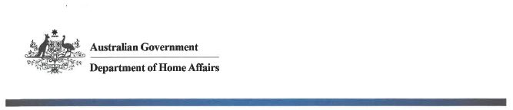

NTC-14542

**Aviation Transport Security Act 2004**

**EXEMPTION FROM DISPLAYING AN AVIATION SECURITY IDENTIFICATION CARD** **IN A SECURE Area – PERTH AIRPORT**

1. I, **JACQUELINE IRELAND**, Director, Transport Security Operations, Office of Transport Security, under regulation 3.08 of the Aviation Transport Security Regulations 2005:
2. **GIVE** a class of persons being registered employees and media guests in the sterile area Terminal 3 (T3) of Perth Airport, an exemption from displaying an Aviation Security Identification Card (ASIC) for:

* Film and photography shoot of the newly completed Terminal 3 (T3) facility and International Transit Lounge.

This notice is subject to the following conditions:

1. all class of person entering the area will be accounted for by way of register; and
2. all class of person entering the area will be subjected to security screening; and
3. all persons will be contained within the sterile area of Perth Airport Terminal 3 (T3).
4. This notice will be in force between 1000 hours and 1400 hours on 23 March 2018.

Date: 20 March 2018

Jacqui Ireland

Delegate of the Secretary of the

Department of Home Affairs

Note:

1. *Gazette* means the *Commonwealth of Australia Gazette*
2. This Notice remains in force until otherwise revoked in writing and upon subsequent publication in the *Gazette*