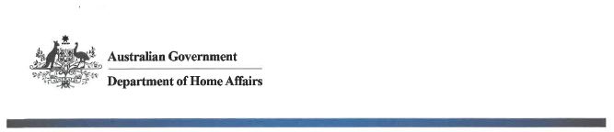

NTC-14543

Aviation Transport Security Regulations 2005

EXEMPTION FROM DISPLAYING AN AVIATION SECURITY IDENTIFICATION CARD IN AN Airside area

I, JACQUELINE IRELAND, Director Transport Security Operations, Office of Transport Security, under regulation 3.08 of the Aviation Transport Security Regulations 2005, GIVE persons attending the Canberra Airport open day at Canberra Airport, an exemption from displaying an Aviation Security Identification Card (ASIC) when undertaking airside tours during the event.

This exemption operates from 06:00 hours to 17:00 hours, 08 April 2018.

This Notice is issued on condition that:

- all tour passengers are subject to screening by hand held metal detector and a physical bag search prior to boarding the tour bus,
- all tour passenger who do not hold a valid ASIC have a valid ticket for the tour,
- buses are subject to the airside inspection process at Gate 5 prior to entering the airside area, and
- buses are subject to a visual inspection of the cabin and cargo hold on the completion of
each tour.

Date: 22 March 2018

Jacqui Ireland
Delegate of the Secretary of the
Department of Home Affairs

