Heavy Vehicle National Law

Victoria Class 1 4-Axle & 5-Axle All Terrain Mobile Crane Mass and Dimension Exemption Notice 2018 (No.1)

1. Purpose

This Notice exempts the stated Class 1 heavy vehicles from the prescribed mass requirements and prescribed dimension requirements specified in the Notice, subject to the conditions specified in the Notice.

*Note: This notice introduces amended axle spacing and ground clearance width dimensions.*

1. Revocation

This Notice revokes and replaces the *Victoria Class 1 4-Axle & 5-Axle All Terrain Mobile Crane Mass and Dimension Exemption Notice 2016 (No 1).*

1. Authorising provision

This Notice is made under section 117 of the Heavy Vehicle National Law.

1. Commencement

This Notice commences on the date of its publication.

1. Expiry

This Notice expires on five years after commencement.

1. Title

This Notice may be cited as the *Victoria Class 1 4-Axle & 5-Axle All Terrain Mobile Crane Mass and Dimension Exemption Notice 2018*.

1. Definitions
   1. Unless otherwise stated, words and expressions used in this Notice have the same meanings as those defined in the HVNL.
   2. A reference in this Notice to a heavy vehicle includes a reference to its load except where the context or subject otherwise indicates or requires.
   3. In this Notice—

all terrain mobile crane means a special purpose vehicle that has all of the following features and requirements—

1. is a mobile crane with either 4 axles or 5 axles; and
2. has two tyres per axle; and
3. has at least 50% of its axles steerable; and
4. is not a truck mounted special purpose vehicle; and
5. has on road and off road capability; and
6. has separate driving and crane operating compartments.

axle spacing means the distance between the centre of an axle and the centre of another axle.

eligible vehicle means an all-terrain mobile crane that complies with the requirements of this Notice.

ground contact width means—

1. in relation to an axle, the distance between the outermost point of ground contact of the outside tyres on each end of the axle; or
2. in relation to an axle group, the greatest ground contact width of all the axles in the group.

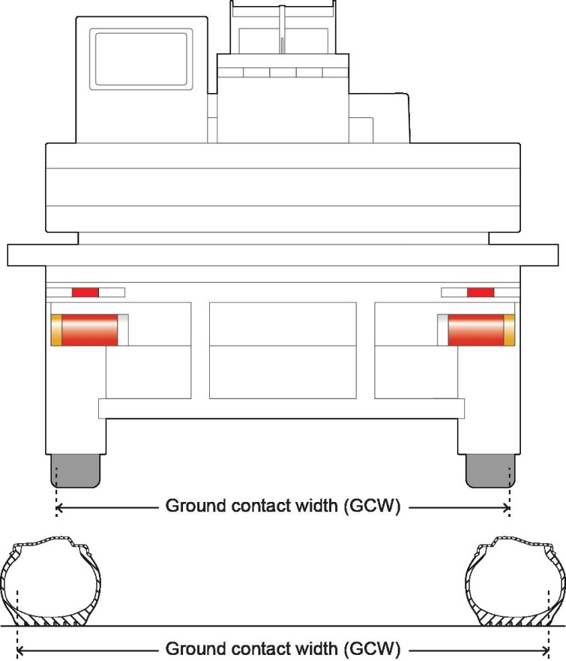

Figure - Illustration of ground contact width of an axle

HVNL means the Heavy Vehicle National Law.

MDL National Regulation means the Heavy Vehicle (Mass, Dimension and Loading) National Regulation.

1. Application

This Notice applies to an eligible vehicle operating in Victoria.

Note: Nothing in this Notice exempts the driver or operator of an eligible vehicle from complying with legislation regulating the use of heavy vehicles, including, but not limited to, compliance with-

* all mass and dimension requirements in the HVNL, other than the mass or dimension requirements from which the vehicle is exempted under this Notice—
* traffic signs, including mass and dimension limit traffic signs—
* vehicle standards in the HVNL— and
* lawful directions of authorised officers.

1. Exemption from compliance with Heavy Vehicle Standards

Unless otherwise stated in a state schedule, a 4-Axle & 5-Axle All Terrain Mobile Crane complying with the dimension requirements outlined in Schedule 11 of this Notice is exempt from compliance with Schedule 2, section 34(1) of the Heavy Vehicle (Vehicle Standards) National Regulation.

1. Exemption from prescribed mass requirements

An eligible vehicle is exempt from the following mass requirements of Schedule 1 to the MDL National Regulation—

* + 1. section 2(1)(a)(iv) and 2(1)(b)—
    2. section 4 and Table 1 (Axle mass limits table)— and
    3. section 5(1) and Table 2 (Axle spacing mass limits general table).

1. Exemption from prescribed dimension requirements

An eligible vehicle is exempt from the following dimension requirements of Schedule 6 of the MDL National Regulation—

* + 1. section 3(1)(g); and
    2. section 5(1)(c); and
    3. section 7(1); and
    4. section 13(a)(i).

1. Dimension requirements – general

An eligible vehicle must not exceed any of the following dimension limits—

* + 1. 16.5m length;
    2. rear overhang of the lesser of 4.0m and 90% of the wheelbase;
    3. 3.5m width;
    4. a projection in front of the centre of the steering wheel of 3.5m.

1. Dimension Requirements – axle spacing
   1. An eligible vehicle with 4 axles must meet the dimension requirements in Table 1. When reading Table 1, for a given Gross Vehicle Mass (GVM) in Column 1, a vehicle must meet or exceed the axle spacing limits in Columns 2 to 5.

Table – Minimum Axle Spacing, Axle Mass Limits and Ground Contact Width for a 4 Axle All Terrain Mobile Crane

|  |  |  |  |  |  |  |
| --- | --- | --- | --- | --- | --- | --- |
| **Column 1** | **Column 2** | **Column 3** | **Column 4** | **Column 5** | **Column 6** | **Column 7** |
| **GVM (t)** | **Minimum axle spacing (mm)** | | | | **Maximum mass limit per axle (t)** | **Minimum GCW (mm)** |
| **Axle 1-4** | **Axle 1-2** | **Axle 2-3** | **Axle 3-4** |
| 42.0 | 5300 | 1650 | 2000 | 1650 | 12.0 | 2470 |
| 44.0 | 2510 |
| 45.0 | 2550 |
| 46.0 | 2590 |
| 47.0 | 2630 |
| 48.0 | 2670 |

* 1. An eligible vehicle with 5 axles must meet the dimension requirements in Table 2. When reading Table 2, for a given Gross Vehicle Mass (GVM) in Column 1, a vehicle must meet or exceed the axle spacing limits in Columns 2 to 6.

Table – Minimum Axle Spacing, Axle Mass Limits and Ground Contact Width for a 5 Axle All Terrain Mobile Crane

|  |  |  |  |  |  |  |  |
| --- | --- | --- | --- | --- | --- | --- | --- |
| **Column 1** | **Column 2** | **Column 3** | **Column 4** | **Column 5** | **Column 6** | **Column 7** | **Column 8** |
| **GVM (t)** | **Minimum axle spacing (mm)** | | | | | **Maximum mass limit per axle (t)** | **Minimum GCW (mm)** |
| **Axle 1-5** | **Axle 1-2** | **Axle 2-3** | **Axle 3-4** | **Axle 4-5** |
| 50.0 | 7250 | 2450 | 1600 | 1600 | 1600 | 10.0 | 2750 |
| 54.0 | 7750 | 2450 | 1650 | 2000 | 1650 | 12.0 | 2670 |
| 56.0 | 2720 |
| 57.0 | 2770 |
| 58.0 | 2820 |
| 59.0 | 2870 |
| 60.0 | 2920 |

1. Mass requirements – axle mass limits
   1. The mass of an eligible 4 axle vehicle whose axle spacing complies with Table 1, must not be more than the axle mass limit set out in Column 6 of Table 1.
   2. The mass of an eligible 5 axle vehicle whose axle spacing complies with Table 2, must not be more than the axle mass limit set out in Column 7 of Table 2.
2. Other conditions
   1. An eligible vehicle is subject to the conditions in Schedule 8 - Conditions of mass or dimension exemptions applying to Class 1 heavy vehicles of the MDL National Regulation.
   2. The section width of each tyre on an eligible vehicle must be at least 445mm.
   3. If an eligible vehicle has the centre of a steering control to the left of the vehicle it must—
      1. display a ‘left hand drive’ sign that complies with section 31 of Schedule 2 to the Heavy Vehicle (Vehicle Standards) National Regulation on the rear of the vehicle; and
      2. either—
         1. be fitted with a closed circuit television system that provides the driver with an adequate view to the right rear quarter of the vehicle; or
         2. be accompanied by a pilot vehicle.
   4. During travel—
      1. the eligible vehicle’s compliance with the following conditions must be monitored by an approved intelligent transport system used by an intelligent access service provider—
         1. the vehicle’s use only on roads authorised by this Notice; and
         2. the vehicle’s compliance with any conditions of use of a road under this Notice; and
      2. any non-compliance reports made by the system must be sent to the Regulator within 7 days.

Note–

The point of contact for noncompliance reports is VicRoads on (03) 9881 8702.

1. Approved Routes

An eligible vehicle may only use the approved routes, and the approved routes with conditions, on the map titled ‘4 & 5 Axle All Terrain Mobile Crane Network’ (the approved routes), and under any conditions and limitations specified for those routes.

Note–

The “4 & 5 Axle All Terrain Mobile Crane Network” map is located at <https://www.vicroads.vic.gov.au/business-and-industry/heavy-vehicle-industry/heavy-vehicle-map-networks-in-victoria>.

If travel is required on a route other than a route permitted under this Notice, a mass or dimension exemption (permit) must be obtained from the National Heavy Vehicle Regulator for travel on that route.

1. Other Route Restrictions
   1. Notwithstanding section 15–
      1. an eligible vehicle must not use any part of an approved route consisting of a timber deck bridge;
      2. an eligible vehicle that has a maximum speed capability of 60km/h or less, may not be used on any freeway or tollway on the approved routes;
      3. an eligible vehicle that has a maximum speed capability greater than 80km/h may use all the freeways and tollways on the approved routes;
      4. For the purposes of subsection (b), (c) and (d), the maximum speed capability of a crane is the maximum speed the crane is able to reach on a horizontal surface, as determined by the crane manufacturer.
2. Conditions applying to particular routes
   1. An eligible vehicle may not use the approved routes more than twice per day, being once on the inbound journey and once on the outbound journey.
   2. Where practical and safe to do so, an eligible vehicle must avoid being on a bridge at the same time as a B-double, a Class 1 heavy vehicle or a Class 3 heavy vehicle.
   3. The following conditions apply if an eligible vehicle operating under this Notice is used on tollways—
      1. for travel on CityLink, the operator of the vehicle must—
         1. as soon as practicable, contact CityLink on Tel: (03) 9674 2001 or Fax (03) 9674 2060 to advise of the intended movement of that vehicle and obtain a reference number; and
         2. at least 30 minutes before the vehicle is to be used on CityLink, telephone CityLink on (03) 9674 2001 to confirm the intended travel and to obtain advice on traffic conditions, any road works and lane closures.
      2. for travel on EastLink, the operator of the vehicle must—
         1. as soon as practicable contact EastLink on Tel: (03) 9955 1900 or Fax: (03) 9955 1907 to advise of the intended movement and obtain a reference number; and
         2. at least 30 minutes before the vehicle is to be used on EastLink contact EastLink on (03) 9955 1900 to confirm the intended travel and obtain advice on traffic conditions, any road works and lane closures.
   4. If an eligible vehicle is wider than 3.0m, before attempting to cross a railway track and/or a tramway track, the driver or operator of the vehicle must first obtain permission from the Transport Compliance Unit of the Department of Transport Planning and Local Infrastructure. (Tel: 96556134 - Mob 0417 054 626).

**Dated: 13 June 2018**

Peter Caprioli

*Executive Director (Access Operations)*

**National Heavy Vehicle Regulator**