

**Government House**

**CANBERRA ACT 2600**

**26 June 2018**

The Governor-General is pleased to announce the following honorary appointment within the Military Division of the Order of Australia:

## ORDER OF AUSTRALIA

# *Honorary Officer (AO) in the Military Division*

# General Joseph F DUNFORD Jr, United States of America

For distinguished service to the military relationship between Australia and the United States through leadership, passion and strategic foresight, and in recognition of his efforts to enhance the longstanding defence Alliance between Australia and the United States.

# By His Excellency’s Command

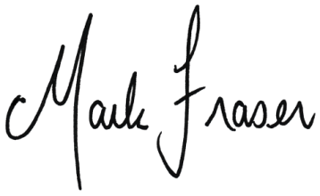

**Mark Fraser LVO OAM**

Official Secretary to the Governor-General

APPOINTED AN HONORARY OFFICER (AO)

**IN THE MILITARY DIVISION OF THE ORDER OF AUSTRALIA**

# General Joseph F DUNFORD Jr, United States of America

For distinguished service to the military relationship between Australia and the United States through leadership, passion and strategic foresight, and in recognition of his efforts to enhance the longstanding defence Alliance between Australia and the United States.

# Through his distinguished career, General Dunford has ensured that the Australia-United States Alliance has gone from strength to strength. General Dunford has personally contributed to the strength of our bilateral relationship, safeguarding the Alliance as an agile and fundamental contributor to security of the Indo-Pacific region. In particular, his leadership and willingness to work closely when discussing issues with Australia have ensured that our Alliance remains focused and premised on powerful outcomes.