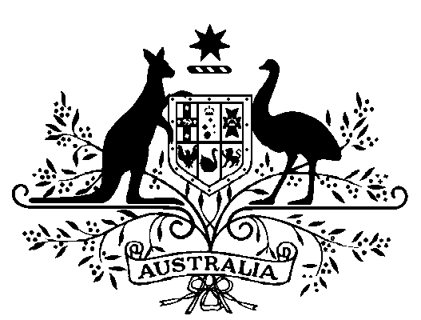

Great Barrier Reef Marine Park Authority – Part-Time Member - Appointment 2018
I, General the Honourable Sir Peter Cosgrove AK MC (Ret’d), Governor-General of the Commonwealth of Australia, acting with the advice of the Federal Executive Council and under Subsection 10(2) of the Great Barrier Reef Marine Park Act 1975, appoint Mr David Stewart as a part-time member of the Great Barrier Reef Marine Park Authority for a period of five years beginning on 23 July 2018.
Dated 21 June 2018
Peter Cosgrove
Governor-General
By His Excellency’s Command
Josh Frydenberg
Minister for the Environment and Energy

