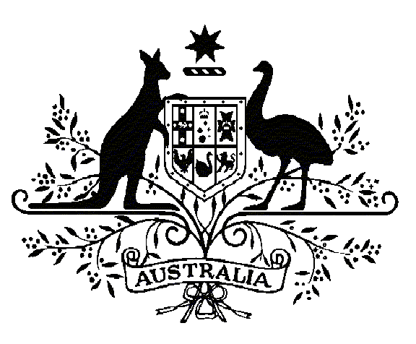

Specialist Medical Review Council

Declarations

*Section 196W  
Veterans’ Entitlements Act 1986*

**Re: Statements of Principles Nos. 55 and 56 of 2014**

**in respect of Chronic Multisymptom Illness**

Request for Review Declaration No. 33

In relation to the Repatriation Medical Authority (the RMA) Statements of Principles Nos. 55 and 56 of 2014 concerning chronic multisymptom illness made under subsections 196B of the Veterans' Entitlements Act 1986 (the VEA), the Council under subsection 196W(5) of the VEA:

DECLARES that there is insufficient sound medical-scientific evidence on which the RMA could have relied to amend the Statements of Principles to include the following factor(s):

* depleted uranium;
* oil well smoke;
* medical countermeasures (such as pyridostigmine bromide, and vaccinations for anthrax, plague, pertussis);
* contaminated food and water;
* chemical and biological weapons; and
* pesticide exposure (including N,N-diethyl-m-toluamide (DEET)).

|  |  |  |
| --- | --- | --- |
|  |  |  |
| David Newman  Presiding Councillor | Bradley Ng  Councillor | Andrew Grulich  Councillor |
|  |  |  |
| Dino Pisaniello  Councillor | John Waterston  Councillor |  |

|  |  |  |
| --- | --- | --- |
|  | | |
|  | | |
| |  |  | | --- | --- | | The Common Seal of the ) Specialist Medical Review ) Council was affixed by )  authority of the Council in )  the presence of: ) |  | | |  |

|  |
| --- |
|  |
|  |
| Jan Bowman  Registrar, SMRC  Dated this ***sixth*** day of ***August 2018*** |