***Customs Act 1901***

**Notice under Paragraph 15(2)(a)**

**Wharf Notice of Appointment (No. 2609) – Chith Export Facility, Weipa**

I, Melissa Bennett, delegate of the Comptroller-General of Customs, under paragraph 15(2)(a) of the *Customs Act 1901*:

1. APPOINT as a wharf in the Port of Weipa, in the state of Queensland, the area currently known as Chith Export Facility; and
2. FIX as the limits of that wharf the area within the red boundary line indicated in **Attachment A** to this notice.

Dated the 13th day of September 2018.

Signed

Melissa Bennett

Acting Assistant Secretary

Traveller Branch

Trade and Customs Division

Department of Home Affairs

**Attachment A**

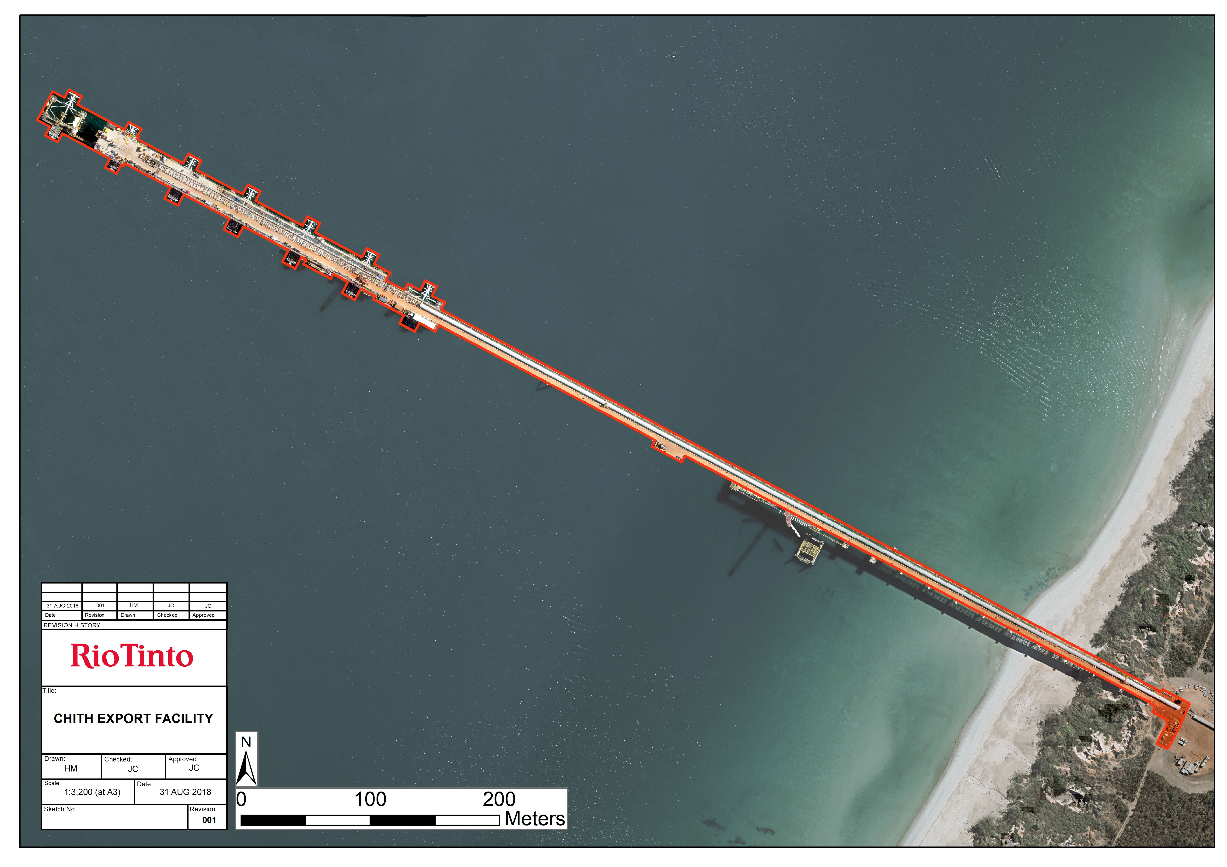

Gulf of Carpentaria

CHITH EXPORT FACILITY

PARAGRAPH 15(2)(a) OF THE *CUSTOMS ACT 1901* WHARF LIMITS

CHITH EXPORT FACILITY, PORT OF WEIPA

WHARF LIMIT

Notice NO. 2609

APPROXIMATE SCALE 1:3,200 (at A3)