|  |  |  |
| --- | --- | --- |
| Commonwealth Coat of Arms | **Commonwealth of Australia** | **Gazette** |
| Published by the Commonwealth of Australia | | **GOVERNMENT NOTICES** |

***Customs Act 1901***

**Notice under Subsection 234AA(3)**

**Specification of Areas to which section 234AA applies (No. 2615) – Newcastle Airport**

I, Melissa Bennett, delegate of the Comptroller-General of Customs, under subsection 234AA(3) of the *Customs Act 1901* (the Act):

SPECIFY the areas shaded in red in **Attachment A** to this notice at **Newcastle Airport** as areas to which section 234AA of the Act applies.

Dated the 8th day of November 2018.

Signed

Melissa Bennett

Acting Assistant Secretary

Traveller Branch

Trade and Customs Division

Department of Home Affairs

Limits of the area specified under subsection 234AA(3) of the *Customs Act 1901*

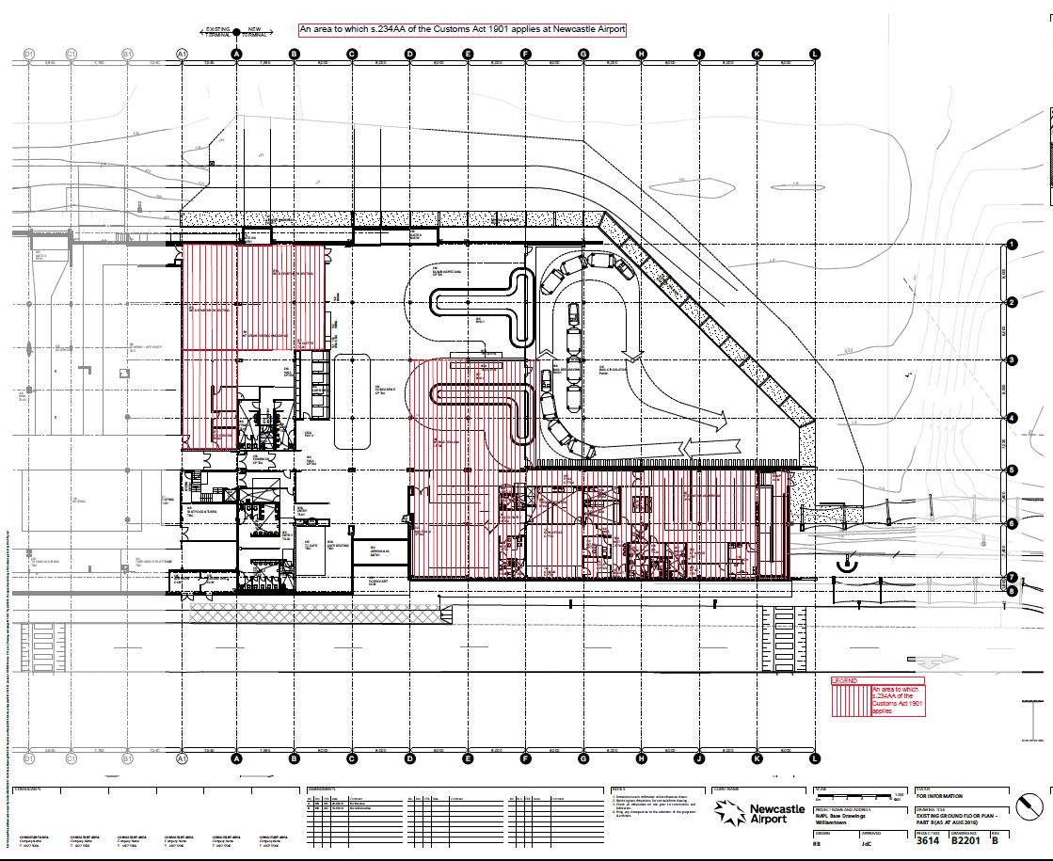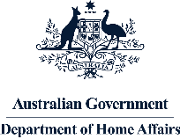

**Attachment A – An area to which section 234AA of the *Customs Act 1901* applies at Newcastle Airport**

Newcastle Airport

SECTION 234AA OF THE *CUSTOMS ACT 1901*

NOTICE NO. 2615