

*Australian Radiation Protection and Nuclear Safety Act 1998*

Australian Radiation Protection and Nuclear Safety Regulations 1999

**Declaration of Exemption**

I, Carl-Magnus Larsson,Chief Executive Officer of the Australian Radiation Protection and Nuclear Safety Agency, acting pursuant to sub-regulation 38(5) of the Australian Radiation Protection and Nuclear Safety Regulations 1999 (the Regulations), am satisfied that the Department of Defence and Australian Defence Force, in dealing with Smoke Detectors containing less than or equal to 40 kBq of Americium-241 not made in accordance with AS 3786:2014: *Smoke Alarms using scattered light, transmitted light or ionization* (AS 3786(2014), satisfy the requirements of paragraphs 38(5)(a) and(b) of the Regulations.

I therefore declare this dealing to be exempt.

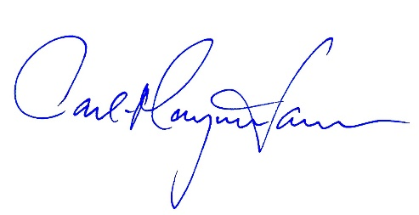

Carl-Magnus Larsson

CEO of ARPANSA

23 November 2018