

Australian Veterans’ Recognition (Putting Veterans and Their Families First) Act 2019

No. 96, 2019

An Act to provide for the recognition of veterans, and for related purposes

Contents

Part 1—Preliminary 2

1 Short title 2

2 Commencement 2

3 Object of this Act 2

4 Definitions 2

Part 2—Recognition of veterans and their families 4

5 General recognition 4

6 Australian Defence Veterans’ Covenant 4

7 Beneficial interpretation of legislation 5

8 Cooperation 5

Part 3—Issue of pins, cards or other artefacts 6

9 Issue of pins, cards or other artefacts 6

Part 4—Other matters 7

10 Part 2 does not create or give rise to rights or obligations 7

11 Act not intended to exclude similar State or Territory laws 7

Schedule 1—Australian Defence Veterans’ Covenant 8



Australian Veterans’ Recognition (Putting Veterans and Their Families First) Act 2019

No. 96, 2019

An Act to provide for the recognition of veterans, and for related purposes

[*Assented to 30 October 2019*]

The Parliament of Australia enacts:

Part 1—Preliminary

1 Short title

This Act is the *Australian Veterans’ Recognition (Putting Veterans and Their Families First) Act 2019.*

2 Commencement

(1) Each provision of this Act specified in column 1 of the table commences, or is taken to have commenced, in accordance with column 2 of the table. Any other statement in column 2 has effect according to its terms.

| Commencement information | | |
| --- | --- | --- |
| Column 1 | Column 2 | Column 3 |
| Provisions | Commencement | Date/Details |
| 1. The whole of this Act | The day after this Act receives the Royal Assent. | 31 October 2019 |

Note: This table relates only to the provisions of this Act as originally enacted. It will not be amended to deal with any later amendments of this Act.

(2) Any information in column 3 of the table is not part of this Act. Information may be inserted in this column, or information in it may be edited, in any published version of this Act.

3 Object of this Act

The object of this Act is to acknowledge the unique nature of military service and the sacrifice demanded of those who commit to defend our nation.

4 Definitions

In this Act:

***Permanent Forces*** has the same meaning as in the *Defence Act 1903*.

***Reserves*** has the same meaning as in the *Defence Act 1903*.

***veteran*** means a person who has served, or is serving, as a member of the Permanent Forces or as a member of the Reserves.

Part 2—Recognition of veterans and their families

5 General recognition

(1) The Commonwealth acknowledges the unique nature of military service and the sacrifice demanded of those who commit to defend our nation.

(2) The Commonwealth acknowledges the demands placed on, and the sacrifices made by, the families of veterans.

(3) The Commonwealth acknowledges that veterans may require support mechanisms to enjoy good health, to access employment and training opportunities, to access appropriate housing, to have access to justice, to enjoy social wellbeing or to participate in community engagement after the end of their military service.

(4) The Commonwealth is committed to supporting veterans and providing the care and support they require.

(5) The Commonwealth acknowledges that support for veterans should be provided in a way that respects their dignity as individuals, enhances their self‑esteem, is sensitive to any physical or mental injury or disease they may have suffered and respects their military service.

(6) The Commonwealth acknowledges that veterans should be supported to achieve greater economic wellbeing and sustainability and greater participation in civic affairs and should have opportunities to participate in employment and education.

6 Australian Defence Veterans’ Covenant

The Parliament, on behalf of the people of Australia, endorses the Australian Defence Veterans’ Covenant set out in Schedule 1.

7 Beneficial interpretation of legislation

(1) The Commonwealth is committed to decision‑makers interpreting a provision of the following legislation in a way that benefits veterans, or their families, where that interpretation is consistent with the purpose of that provision:

(a) the *Veterans’ Entitlements Act 1986*;

(b) the *Military Rehabilitation and Compensation Act 2004* (the ***MRC Act***);

(c) the *Safety, Rehabilitation and Compensation (Defence‑related Claims) Act 1988*;

(d) instruments under those Acts.

(2) The Commonwealth is committed to decision‑makers deciding claims under that legislation:

(a) in a manner that is fair, just and consistent; and

(b) except under the MRC Act—within a time that is proportionate to the complexity of the matter; and

(c) in a manner that promotes public trust and confidence; and

(d) on the basis of only requiring evidence sufficient to meet the relevant standard of proof for the claims.

(3) The Commonwealth is committed to the Military Rehabilitation and Compensation Commission deciding a claim under the MRC Act within 90 days beginning on:

(a) the day the Commission receives the claim; or

(b) the day the Commission receives information, or a document, that the Commission requested in relation to the claim under section 330 of that Act;

whichever occurs later.

8 Cooperation

The Commonwealth is committed to working cooperatively with veterans, their families and ex‑service organisations to address issues facing veterans.

Part 3—Issue of pins, cards or other artefacts

9 Issue of pins, cards or other artefacts

(1) The Commonwealth may issue pins, cards or other artefacts to veterans in recognition of the military service of veterans.

(2) The Commonwealth may issue pins, cards or other artefacts to family members of veterans in recognition of:

(a) the military service of veterans; or

(b) the demands placed on, and the sacrifices made by, the families of veterans.

Part 4—Other matters

10 Part 2 does not create or give rise to rights or obligations

(1) Part 2 does not, by its terms or operation, create or give rise to any rights (whether substantive or procedural), or obligations, that are legally enforceable in judicial or other proceedings.

(2) A failure to comply with Part 2 does not affect the validity of any decision, and is not a ground for the review or challenge of any decision.

(3) No action, suit or proceeding is to be instituted in reliance on the terms of Part 2 or the operation of that Part.

11 Act not intended to exclude similar State or Territory laws

This Act is not intended to apply to the exclusion of any law of a State or Territory that provides for the recognition of veterans or their families.

Schedule 1—Australian Defence Veterans’ Covenant

Note: See section 6.

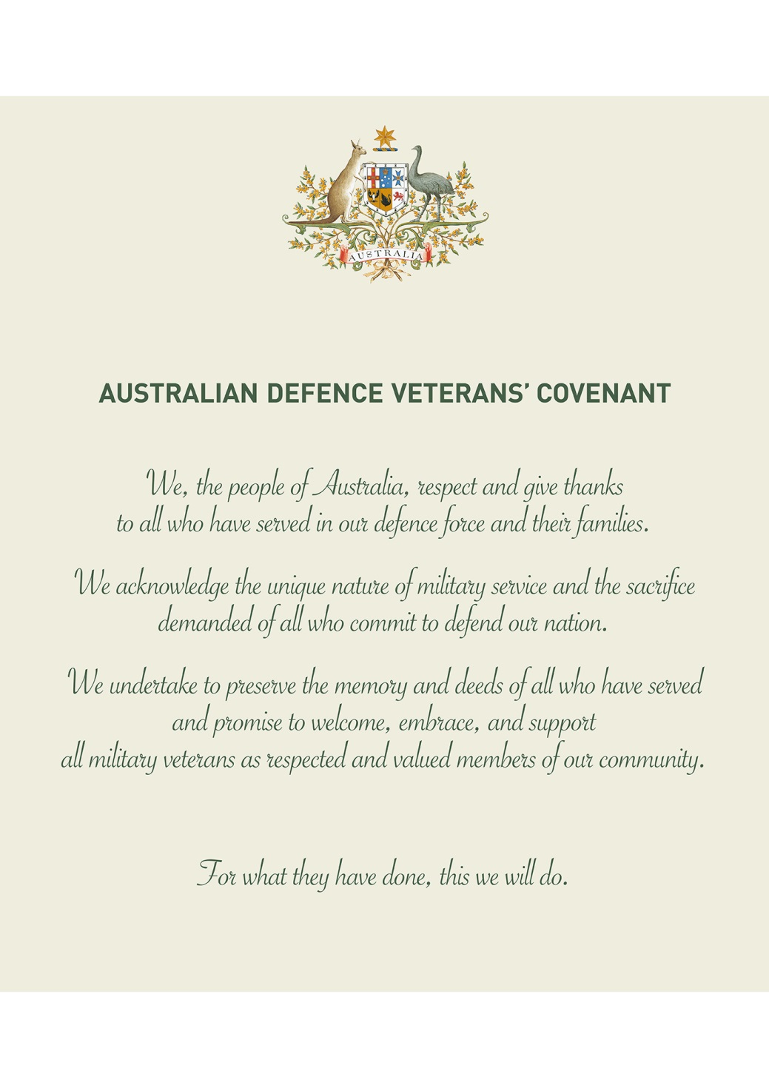

[*Minister’s second reading speech made in—*

*Senate on 4 July 2019*

*House of Representatives on 21 October 2019*]

(89/19)