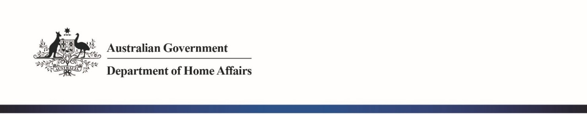

NTC-15851

***Aviation Transport Security Act 2004***

**EXEMPTION FROM DISPLAYING AN AVIATION SECURITY IDENTIFICATION CARD IN A SECURE   
AREA – PERTH AIRPORT**

1. I, **MICHELLE COZADINOS**, Director, Transport Security Operations, Aviation and Maritime Security Division, am authorised under section 127 of the *Aviation Transport Security Act 2004* (the Act)*,* make this notice under the *Aviation Transport Security Regulations 2005* (the Regulations).

This Notice is made under sub-regulation 3.08(3) of the Regulations.

1. I, **GIVE** invited guests of P.T Garuda Indonesia Ltd (Garuda Indonesia Airlines) that are attending the Nyepi Day celebrations for the purpose of viewing an aircraft, an exemption from displaying an Aviation Security Identification Card (ASIC) in the secure area of Perth Airport International Terminal 1.

This exemption operates from 9 am to 1 pm on 7 March 2019 subject to all of the following conditions:

* 1. Invited guests are to produce photo identification to Garuda Indonesia Airlines staff, located at the ‘Perth Airport VIP room’, which is to be reconciled against a guest list; and
  2. Invited guests are to be screened in accordance with the Aviation Screening Notice before being permitted into the sterile area of Terminal 1; and
  3. Whilst in the airside area and on board the display aircraft, invited guests are to be under the escort of:
     + an ASIC holder from Garuda Indonesia Airlines management staff; and
     + the Perth Airport Pty Ltd Duty Airport Operations Manager; and
  4. The exemption is limited to the area consisting of:
     + the aerobridge connecting to the display aircraft at Bay 154 of Terminal 1; and
     + the airside area (also the security restricted area) around Bay 154 including the corridor extending to the landside arrivals area.

Date: 5 March 2019

Michelle Cozadinos

Delegate of the Secretary of the

Department of Home Affairs