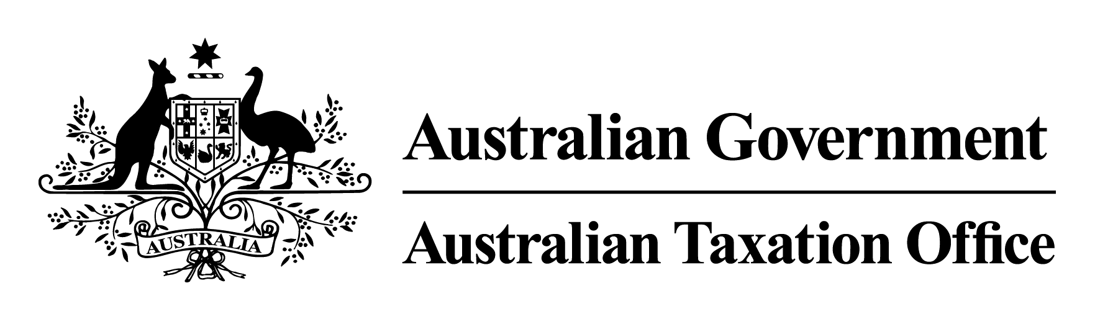
The Commissioner of Taxation, Chris Jordan, gives notice of the following Rulings, copies of which can be obtained from ato.gov.au/law.

NOTICE OF RULINGS
Ruling number | Subject | Brief description
CR 2019/30 | Pinewood Community Financial Services Limited – off-market share buy-back | This Ruling sets out the tax consequences of the off-market share buy-back announced by Pinewood Community Financial Services Limited on 20 December 2018.  This Ruling applies from 1 July 2018.
CR 2019/31 | Caltex Australia Limited – off-market share buy back | This Ruling sets out the tax consequences of the off-market share buy-back announced by Caltex Australia Limited on 26 February 2019.  This Ruling applies from 1 July 2018.
CR 2019/32 | Australian Olympic Committee – medal incentive funding payments | This Ruling outlines the assessability of payments to athletes made by the Australian Olympic Committee under the Medal Incentive Funding Program.  This Ruling applies from 1 July 2019.

