Government House
CANBERRA ACT 2600
31 May 2019

It is notified for general information that the Governor-General has approved the following awards:

COMMENDATION FOR GALLANTRY

Australian Army

Mr (then Corporal) Stephen Geoffrey BLOOMFIELD, QLD
For acts of gallantry in action as a Special Air Service Regiment medical assistant left alone for three days in enemy territory to tend to a severely wounded fellow soldier who had been gored by an elephant in Kalimantan during the Indonesian-Malaysian Confrontation in June 1965.

CONSPICUOUS SERVICE MEDAL (CSM)

Royal Australian Air Force

Mr (then Warrant Officer ) Peter Ian JOHNSON, QLD
For outstanding achievement as a helicopter crewman at Number 5 Squadron, Royal Australian Air Force.

By His Excellency’s Command

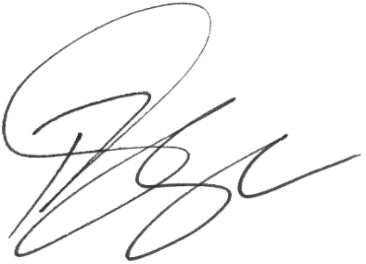
Paul Singer MVO
Official Secretary to the Governor-General

