Description: Commonwealth Coat of Arms

# Ministerial Direction (Commonwealth Director of Public Prosecutions)

## Director of Public Prosecutions Act 1983

I, Christian Porter MP, Attorney-General of Australia, having consulted the Director of Public Prosecutions (' the Director' ), revoke the direction issued to the Director on 30 October 2014 and give the following direction under subsection 8(1) of the *Director of Public Prosecutions Act 1983.*

The Director must not proceed with a prosecution of a person in for alleged contravention of the following sections without the written consent of the Attorney-General:

1. section 35P of the *Australian Security Intelligence Organisation Act 1979*
2. section 3ZZHA, 15HK, l 5HL and 70 of the *Crimes Act 1914*
3. section 131.1 and 132.1 of the *Criminal Code*
4. section 73A of the *Defence Act 1903*

where the person is a journalist and the facts constituting the alleged offence relate to the work of the person in a professional capacity as a journalist.

The number 19

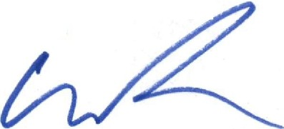Dated September 2019

**The Hon Christian Porter MP Attorney-General**

Parliament House Canberra ACT 2600 • Telephone: (02) 6277 7300 Facsimile: (02) 6273 4102