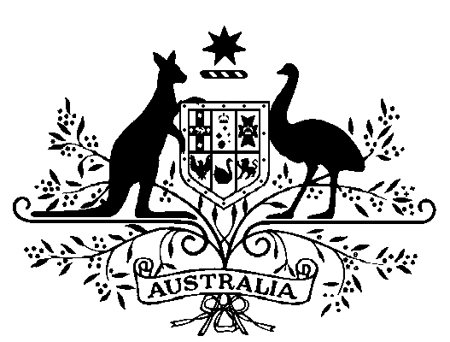

Great Barrier Reef Marine Park Authority –

**Part-Time Member - Appointment 2019**

I, General the Honourable David Hurley AC DSC (Retd), Governor‑General of the Commonwealth of Australia, acting with the advice of the Federal Executive Council and under subsection 10(2) of the *Great Barrier Reef Marine Park Act 1975*, appoint Mr Duane Fraser as a part-time member of the Great Barrier Reef Marine Park Authority for a period of five years beginning on the date of this instrument.

Dated 3 October 2019

David Hurley

Governor‑General

By His Excellency’s Command

Sussan Ley  
Minister for the Environment