*Environment Protection and Biodiversity Conservation Regulations 2000*

Subregulation 12.23 (3)

# PROHIBITION ON ENTERING OR REMAINING IN CERTAIN AREAS OF LORD HOWE MARINE PARK

I, James Findlay, Director of National Parks, under subregulation 12.23(3) of the *Environment Protection and Biodiversity Conservation Regulations* 2000 (**Regulations**), having taken into account and being satisfied that access to certain areas within the Lord Howe Marine Park (**Park**) might endanger public safety, HEREBY PROHIBIT entering or remaining in all areas that comprise the Recreational Use Zone (IUCN IV) of the Park during the times specified in the Schedule, by all persons other than persons acting on behalf, or under the instruction of a Commonwealth agency performing any activity that is reasonably necessary to remove unexploded ordnance from the Park.

**Recreational Use Zone** **(IUCN IV)** means the area described in the Schedule.

Dated this 11 day of May 2020

Dr James Findlay

Director of National Parks

**SCHEDULE**

**RECREATIONAL USE ZONE (IUCN IV)**

All of that area bounded by the line:

1. commencing at the point of latitude 29° 53′ 00″ S, longitude 158° 55′ 00″ E;
2. from there east along the parallel of latitude 29° 53′ 00″ S to its intersection by the meridian of longitude 159° 24′ 00″ E;
3. from there south along that meridian to its intersection with the parallel of latitude 30° 06′ 35″ S;
4. from there west along that parallel to its intersection by the meridian of longitude 158° 55′ 00″ E.
5. then north along that meridian to the point of commencement.

*Note****:*** *Geographic coordinates are expressed in terms of the Geocentric Datum of Australia 1994 (GDA94) as described in the Commonwealth of Australia Gazette GN35 of 6 September 1995.*

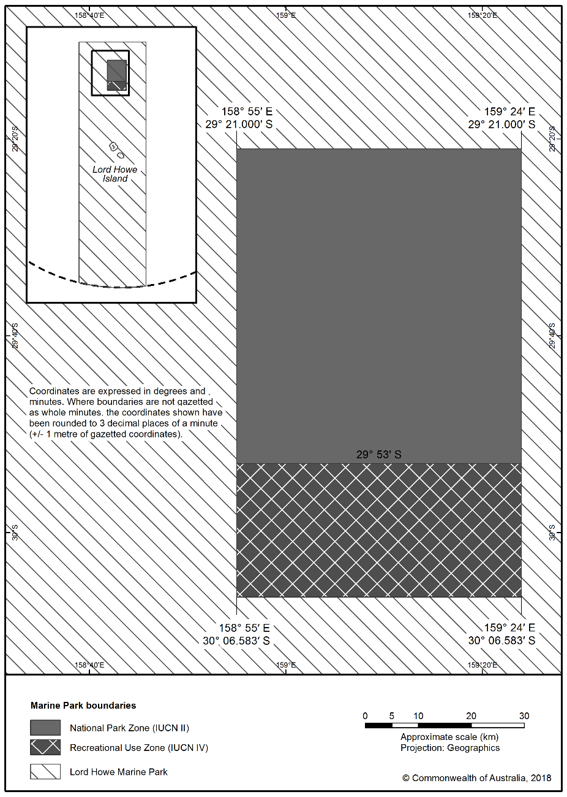

Figure: Graphic of Recreational Use Zone, Lord Howe Marine Park.