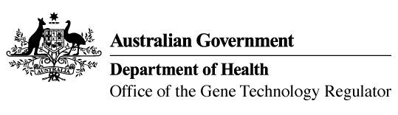
13 July 2020

Invitation to comment on the commercial release
of a genetically modified cotton
Australia’s gene technology regulatory system is designed to protect the health and safety of people and the environment by identifying risks posed by, or as a result of, gene technology and managing those risks.
The Gene Technology Regulator is assessing licence application DIR 173 from Monsanto Australia Pty Ltd (Monsanto) for commercial cultivation of genetically modified (GM) cotton. The GM cotton (MON 88701) contains two introduced genes that confer herbicide tolerance.
Monsanto is seeking approval to commercially grow MON 88701 cotton in all cotton growing areas of Australia. The GM cotton and its products would enter general commerce, including use in human food and animal feed.
A consultation Risk Assessment and Risk Management Plan (RARMP) has been prepared, which concludes that the proposed release would pose negligible risk to human health and safety or to the environment. Draft licence conditions are proposed to ensure ongoing oversight of the release.
The Regulator welcomes written submissions in order to finalise the RARMP, which will then inform the decision on whether or not to issue the licence. The consultation RARMP and related documents can be obtained from the OGTR website under What’s New or by contacting the Office. Please quote application DIR 173 in any correspondence.
Submissions should be received by close of business on 24 August 2020.

Office of the Gene Technology Regulator, MDP 54, GPO BOX 9848 CANBERRA ACT 2601
Telephone: 1800 181 030 E-mail: ogtr@health.gov.au
OGTR website

