**HEAVY VEHICLE NATIONAL LAW**

**National Class 3 Truck and Dog Trailer Mass Exemption Notice 2020 (No.1)**

1. **Purpose**

1. This notice exempts truck and dog trailer combinations from stated prescribed mass requirements in Schedule 1 of the *Heavy Vehicle (Mass, Dimension and* *Loading) National Regulation* (the Regulation), and provide access for those vehicles on specified networks under specified conditions.
2. This Notice revokes and replaces the *National Class 3 Truck and Dog Trailer Mass Exemption Notice 2018.*

*Note: This version of the Notice removes the maintenance requirements in the South Australian Schedule. No other conditions of this Notice are amended.*

1. **Authorising Provision**
2. This notice is made under Section 117 of the Heavy Vehicle National Law (HVNL) as in force in each participating jurisdiction (HVNL).
3. **Commencement**
4. This Notice commences on 1 August 2020.
5. **Expiry**
6. This Notice expires on 21 November 2023.
7. **Definitions**
8. Unless otherwise stated, words and expressions used in this Notice and its Schedules have the same meanings as those defined in the HVNL.
9. In this Notice and its Schedules:-

**Axle Spacing** means the greatest distance between centres of axles in any two axle groups.

**Participating jurisdiction** means the Australian Capital Territory, New South Wales, Queensland, South Australia and Victoria.

**Truck and Dog heavy vehicle** means a combination consisting of a rigid truck with 3 or 4 axles towing a dog trailer with 3 or 4 axles.

1. **Application**
2. This notice applies to a Truck and Dog heavy vehicle where:
3. the combination does not exceed 19m in length; and
4. the truck has a single steer axle or a twin steer axle group at the front, and a dual-drive tandem axle group at the rear; and
5. the dog trailer has either a single axle or a tandem axle group at the front, and a tandem axle group at the rear.
6. **Exemption from prescribed mass requirements**
7. This notice exempts Truck and Dog heavy vehicles from the following general mass limits specified in Schedule 1 of the Regulation:
8. Section 2(1)(a)(iv); and
9. Section 2(4); and
10. Section 5(1).
11. The exemption in this section only applies to the extent of the conditional mass limits set out in this Notice, and when other relevant conditions in the Notice are met.
12. **Condition - General combination mass limits**
13. The mass of a Truck and Dog heavy vehicle must not exceed a mass requirement for the vehicle specified in the Schedules to this Notice.
14. **Conditions - Axle spacing limits**
15. The mass of a Truck and Dog heavy vehicle relating to an axle spacing of the combination, where the combination is more than 42.5t, must not be more than the mass limit stated in:
16. Table 2 (Axle spacing mass limits general table) of Schedule 1 of the Regulation, where the length of the axle spacing is not more than 10m; and
17. Table 1 of this notice, where the length of the axle spacing is more than 10m.
18. The mass limit stated in section (a) or (b) is increased by 0.5t if the axle spacing includes a steer axle to which the steer axle mass exception limits apply.

**Table 1 Extension of axle spacing mass limits general table for axle spacing exceeding 10m**

|  |  |  |
| --- | --- | --- |
| **Length of Axle Spacing (m)** | | **Mass Limit(t)** |
| **At least** | **Less than** |  |
| 10.0 | 10.5 | 42.5 |
| 10.5 | 11.0 | 43.0 |
| 11.0 | 11.5 | 43.5 |
| 11.5 | 12.0 | 44.0 |
| 12.0 | 12.5 | 44.5 |
| 12.5 | 13.0 | 45.0 |
| 13.0 | 13.5 | 45.5 |
| 13.5 | 14.0 | 46.0 |
| 14.0 | 14.5 | 46.5 |
| 14.5 | 15.0 | 47.0 |
| 15.0 | 15.5 | 47.5 |
| 15.5 | 16.0 | 48.0 |
| 16.0 | 16.5 | 48.5 |
| 16.5 | 17.0 | 49.0 |
| 17.0 | 17.5 | 49.5 |
| 17.5 |  | 50.0 |

1. **Condition - Mass ratio**
2. The mass of a dog trailer with 4 axles must not exceed by more than 25 per cent the loaded mass of the towing vehicle.
3. **Condition - Suspension**
4. The drive axle group of the truck and all axles of the dog trailer must be fitted with air suspension with effective dampers.
5. **Other conditions**
6. The driver and operator of the vehicle must comply with all conditions set out in the Schedule for a participating jurisdiction when the vehicle is being used in the jurisdiction to which that Schedule applies.

Peter Caprioli

*Executive Director (Network Operations)*

**National Heavy Vehicle RegulatorSchedule 1: Australian Capital Territory**

1. **Conditions - General mass limits**
2. The mass of a Truck and Dog heavy vehicle operating under the general mass limits must not be more than:
3. in the case of a combination consisting of a rigid truck with 3 axles towing a dog trailer with 3 axles – 48t;
4. in the case of a combination consisting of a rigid truck with 4 axles towing a dog trailer with 3 axles – 50t;
5. in the case of a combination consisting of a rigid truck with 3 or 4 axles towing a dog trailer with 4 axles – 50t.
6. **Conditions -  General mass limits, and steer axle mass exception limits**
7. The mass of a Truck and Dog heavy vehicle operating under this notice and the steer axle mass exception limits must not be more than:
8. in the case of a combination consisting of a rigid truck with 3 axles towing a dog trailer with 3 axles – 48.5t;
9. in the case of a combination consisting of a rigid truck with 3 axles towing a dog trailer with 4 axles – 50.5t
10. **Conditions - Other mass requirements**
11. The loaded mass of a 3 Axle dog trailer may not exceed by more than 25% the loaded mass of the truck.

*Note: Section 11 of this Notice permits a dog trailer with 4 axles to have a mass that is 25 per cent of the loaded mass of the towing vehicle.*

1. **Conditions - General**
2. The extreme axle spacing for a dog trailer with 3 axles must be at least 4.3m.
3. The height of the load on a dog trailer with 3 axles must not exceed 3.5m.
4. The Truck and Dog heavy vehicle must be capable of starting on a 10 percent gradient and maintaining 70km/h on a one percent gradient.
5. **Conditions - Stated routes and areas**
6. An eligible vehicle may access approved routes on the *Approved Routes for National Class 3 Heavy Vehicles 19m Truck & Dog Trailer Combination Mass Exemption* published by the Transport Canberra and City Services (ACT).

**Schedule 2: New South Wales**

1. **Conditions - General mass limits**
2. The mass of a Truck and Dog heavy vehicle operating under the general mass limits must not be more than:
3. in the case of a combination consisting of a rigid truck with 3 axles towing a dog trailer with 3 axles – 48t;
4. in the case of a combination consisting of a rigid truck with 4 axles towing a dog trailer with 3 axles – 50t;
5. in the case of a combination consisting of a rigid truck with 3 or 4 axles towing a dog trailer with 4 axles – 50t.
6. **Conditions -  General mass limits, and steer axle mass exception limits**
7. The mass of a Truck and Dog heavy vehicle operating under this notice and the steer axle mass exception limits must not be more than:
8. in the case of a combination consisting of a rigid truck with 3 axles towing a dog trailer with 3 axles – 48.5t;
9. in the case of a combination consisting of a rigid truck with 3 axles towing a dog trailer with 4 axles – 50.5t
10. **Conditions - Other mass requirements**
11. The loaded mass of a 3 Axle dog trailer may not exceed by more than 25% the loaded mass of the truck.

*Note: Section 11 of this Notice permits a dog trailer with 4 axles to have a mass that is 25 per cent of the loaded mass of the towing vehicle.*

1. **Conditions - General**
2. The extreme axle spacing for a dog trailer with 3 axles must be at least 4.3m.
3. The height of the load on a dog trailer with 3 axles must not exceed 3.5m.
4. The Truck and Dog heavy vehicle must be capable of starting on a 10 percent gradient and maintaining 70km/h on a one percent gradient.
5. **Conditions - Stated routes and areas**
6. The exemption applies to all roads in New South Wales.

**Schedule 3: Queensland**

1. **Conditions - General mass limits**
2. The mass of a Truck and Dog heavy vehicle operating under the general mass limits must not be more than:
3. in the case of a combination consisting of a rigid truck with 3 or 4 axles towing a dog trailer with 3 axles – 45t;
4. in the case of a combination consisting of a rigid truck with 3 or 4 axles towing a dog trailer with 4 axles – 50t.
5. **Conditions -  General mass limits, and steer axle mass exception limits**
6. The mass of a Truck and Dog heavy vehicle operating under this notice and the steer axle mass exception limits must not be more than:
7. in the case of a combination consisting of a rigid truck with 3 axles towing a dog trailer with 3 axles – 45.5t;
8. in the case of a combination consisting of a rigid truck with 3 axles towing a dog trailer with 4 axles – 50.5t
9. **Condition - Vehicle and combination axle spacings**
10. Mass limits relating to individual axle spacings shall not exceed the limits shown in Table 1 of this Notice, and as pursuant to s10 of the Notice.
11. Individual axle spacing in a combination vehicle is:
12. The distance from the centre of any single axle to the centre of the furthest axle in any axle group; or
13. The greatest distance between the centres of axles in any two axle groups
14. The mass limits in Table 1 apply to the sum of the masses on each axle group or single axle within the distance in the table, including the axles between which the distance is measured, as shown in Figure 1.

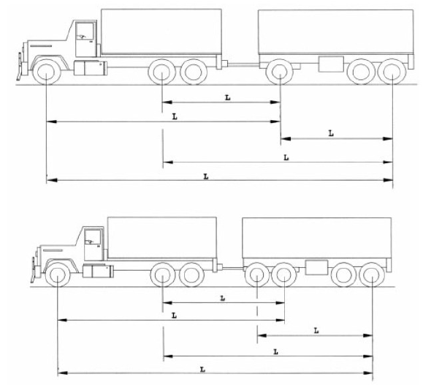

**Figure#1 Examples of the calculation of minimum axle group spacing**

1. **Conditions - General**
2. The extreme axle spacing for a dog trailer with 3 axles must be a minimum of 3.8m.
3. The Truck and Dog heavy vehicle must be capable of starting on a 10 percent gradient and maintaining 70km/h on a one percent gradient.
4. The power to mass ratio for a Truck and Dog heavy vehicle consisting of a rigid truck with 3 or 4 axles towing a dog trailer with 4 axles must not be less than 6.4 brake horse power per tonne or 4.8 kilowatts per tonne.

*Note: For example, an engine with a 320 brake horsepower rating is required for a Truck and Dog heavy vehicle operating at 50 tonne.*

1. **Conditions - Areas or routes**
2. The exemption applies to all roads in Queensland unless otherwise restricted.

**Schedule 4: South Australia**

1. **Conditions - General mass limits**
2. The mass of a Truck and Dog heavy vehicle operating under the general mass limits must not be more than:
3. in the case of a combination consisting of a rigid truck with 3 or 4 axles towing a dog trailer with 3 axles – 45t;
4. in the case of a combination consisting of a rigid truck with 3 or 4 axles towing a dog trailer with 4 axles – 50t.
5. **Conditions -  General mass limits, and steer axle mass exception limits**
6. The mass of a Truck and Dog heavy vehicle operating under this notice and the steer axle mass exception limits must not be more than:
7. in the case of a combination consisting of a rigid truck with 3 axles towing a dog trailer with 3 axles – 45.5t;
8. in the case of a combination consisting of a rigid truck with 3 axles towing a dog trailer with 4 axles – 50.5t
9. **Conditions - Other mass requirements**
10. The mass of a 3 axle dog trailer in the combination must not be more than 22.5t.
11. The mass of a dog trailer with 3 axles in the combination must not be more than the mass of the towing vehicle.
12. The mass of a 4 axle dog trailer in the combination must not be more than 27.5t.
13. **Conditions - Other axle spacing requirements**
14. The truck and dog heavy vehicle must comply with the axle spacing limits shown in the

vehicle configuration figures (1-4) below for the respective rigid truck and dog trailer combinations.

*Note: Except where stated otherwise, all dimensions must be equal to or greater than those specified.*

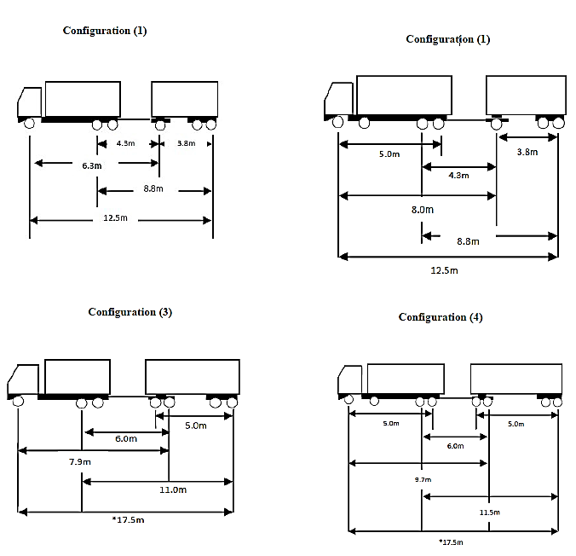

**Figures 1: Axle spacing dimensions for particular vehicle configurations**

*\*The gross mass of the combination reduces by 0.5t for each 0.5 metres reduction in extreme axle spacing*

1. **Conditions - General**
2. The power to mass ratio for a Truck and Dog heavy vehicle must not be less than 6.4 brake horse power per tonne or 4.8 kilowatts per tonne.

*Note: For example, an engine with a 320 brake horsepower rating is required for a Truck and Dog heavy vehicle operating at 50 tonne.*

1. The length of the dog trailer drawbar when measured from the centreline of the towing pivot to the centreline of the leading axle or axle group of the trailer must be longer than 3m but not longer than 5m.
2. **Conditions - Areas or routes**
3. A Truck and Dog heavy vehicle may use all roads in South Australia, except:
4. in the case of a combination which has a total of six axles, travel is not permitted on the following bridge structures—
5. Gumeracha Bridge – Over River Torrens on Torrens Velley Road between Chain of Ponds and Gumeracha
6. Murray Bridge – Over the River Murray at Murray Bridge (old bridge)
7. Spring Creek Bridge – 8.7km south of Wilmington on Main North Road
8. Birkenhead Bridge – Nelson Street, over Port River at Port Adelaide (the lifting bridge)
9. Railway Bridge at Gawler – On Overway Bridge Road, Gawler

**Schedule 5: Victoria**

1. **Conditions - General mass limits**
2. The mass of a Truck and Dog heavy vehicle operating under the general mass limits must not be more than:
3. in the case of a combination consisting of a rigid truck with 3 or 4 axles towing a dog trailer with 3 axles – 45t;
4. in the case of a combination consisting of a rigid truck with 3 or 4 axles towing a dog trailer with 4 axles – 50t.
5. **Conditions -  General mass limits, and steer axle mass exception limits**
6. The mass of a Truck and Dog heavy vehicle operating under this notice and the steer axle mass exception limits must not be more than:
7. in the case of a combination consisting of a rigid truck with 3 axles towing a dog trailer with 3 axles – 45.5t;
8. in the case of a combination consisting of a rigid truck with 3 axles towing a dog trailer with 4 axles – 50.5t
9. **Conditions - Other mass requirements**
10. The mass of a 3 axle dog trailer in the combination must not be more than 22.5t.
11. The mass of a 4 axle dog trailer in the combination must not be more than 27.5t.
12. In the case of a combination consisting of a rigid truck with 3 or 4 axles towing a dog trailer with 3 axles:
13. the wheelbase of the motor vehicle must be a minimum of 4.3m; and
14. the distance from the centre of the front axle of the dog trailer to the centre of the rear axle of the dog trailer must be a minimum of 3.8m.
15. In the case of a combination consisting of a rigid truck with 3 or 4 axles towing a dog trailer with 4 axles:
16. the wheelbase of the truck must be a minimum of 4·5m and the wheelbase of the dog trailer must be a minimum of 5m; or
17. the wheelbase of the truck must be a minimum of 4·9m and the wheelbase of the dog trailer must be a minimum of 4·5m.
18. **Conditions - General**
19. The power to mass ratio for a Truck and Dog heavy vehicle consisting of a rigid truck with 3 or 4 axles towing a dog trailer with 4 axles must not be less than 6 kilowatts per tonne.
20. In this section, power to mass ratio means the power of the truck’s engine compared to the mass of the combination
21. **Condition - Stated Routes and Areas**
22. The exemption applies to all roads in Victoria.