Government House

CANBERRA ACT 2600

31 July 2020

AUSTRALIAN INTELLIGENCE MEDAL

It is notified for general information that Her Majesty The Queen has approved the establishment of the Australian Intelligence Medal (as detailed in the following Letters Patent and Regulations).

The Medal is to be worn immediately after the Australian Corrections Medal.

A copy of the Australian Intelligence Medal Regulations 2020 will be available on the Governor-General's website at www.gg.gov.au

By Her Majesty’s Command

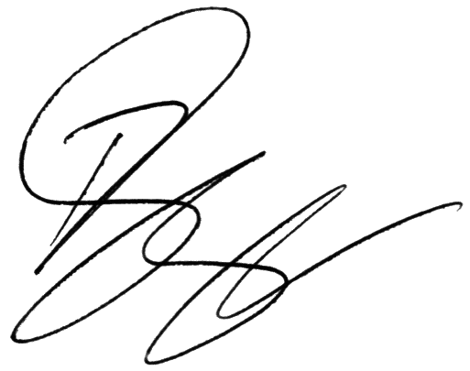

Paul Singer MVO
Official Secretary to the Governor-General

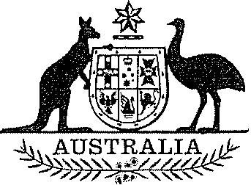
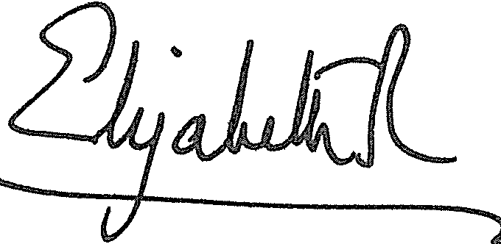

ELIZABETH THE SECOND, by the Grace of God Queen of Australia and Her other Realms and Territories, Head of the Commonwealth:

TO ALL to whom these Presents shall come, GREETING:
WHEREAS it is desirable that there be instituted an Australian medal for the purpose of according recognition to members of Australia's national intelligence community for distinguished service:

KNOW YOU that We do, by these Presents, institute a medal to be called the Australian Intelligence Medal:

AND WE DO ordain that the award of the Australian Intelligence Medal is to be governed by the Regulations set out in the Schedule.

IN WITNESS whereof, We have caused these Our Letters to be made Patent.

GIVEN under the Great Seal of Australia at Our Court at St
James's on 24 June 2020

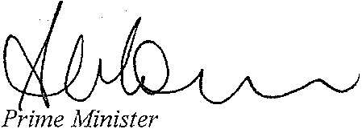
By Her Majesty's Command
\

Schedule

Australian Intelligence Medal Regulations 2020

1 Name
These are the Australian Intelligence Medal Regulations 2020.

2 Definitions
In these Regulations:
agency with an intelligence role or function means:
(a) AUSTRAC (within the meaning of the Anti-Money Laundering and Counter-Terrorism Financing Act 2006); or
(b) the Australian Federal Police; or
(c) the Department of Home Affairs; or
(d) the Defence Department (other than the Australian Geospatial-Intelligence Organisation or the Defence Intelligence Organisation);
to the extent that the agency:
(e) collects, correlates, analyses, produces or disseminates intelligence that relates, or may relate, to national intelligence priorities, requirements or capabilities; or
(f) either:
(i) maintains a capability that materially assists in doing any of the things mentioned in paragraph (e); or
(ii) is developing a capability that is designed to materially assist in doing any of the things mentioned in paragraph (e).
Note: The Defence Department does not include the Australian Defence Force.
Committee means the Australian Intelligence Medal Committee comprised under regulation 11.
Defence Department means the Department administered by the Defence Minister.
Defence Minister means the Minister responsible for administering the Defence Act 1903.
Department of Home Affairs means the Department administered by the Home Affairs Minister.
Home Affairs Minister means the Minister administering the Australian Border Force Act 2015.
intelligence agency means:
(a) the Australian Geospatial-Intelligence Organisation; or
(b) the Australian Secret Intelligence Service; or
(c) the Australian Security Intelligence Organisation; or
(d) the Australian Signals Directorate; or
(e) the Defence Intelligence Organisation; or
(f) the agency known as the Australian Criminal Intelligence Commission; or
(g) the Office of National Intelligence.
Medal means the Australian Intelligence Medal.
member, of the national intelligence community, means:
(a) an officer or employee of:
(i) an intelligence agency; or
(ii) an agency with an intelligence role or function; or
(b) a person who provides services to such an agency, including as a person made available by the Commonwealth, a State or Territory, or any other body or organisation to perform intelligence services for the agency.
national intelligence community means intelligence agencies and agencies with an intelligence role or function.
Prime Minister’s Department means the Department administered by the Prime Minister.
Register means the Register maintained under paragraph 8(2)(a).
Registrar means the Registrar of Awards appointed under subregulation 8(1).

3 Award of Medal
(1) The Medal may be awarded to a person who, as a member of the national intelligence community, has given distinguished service that directly contributed to national intelligence priorities, requirements or capabilities.
(2) The Medal may be awarded regardless of whether the person is eligible for any other award because of the service.
(3) A person who is already the holder of the Medal is not eligible for another award of the Medal.
(4) The number of awards of the Medal in a calendar year must not exceed:
(a) one award for each 1,000, or part of 1,000, full-time equivalent members of the national intelligence community; and
(b) one additional award.
(5) The number of full-time equivalent members is the number of members performing duties on 30 June in the previous calendar year.

4 Making of awards
(1) An award of the Medal must be made by the Governor-General.
(2) The Governor-General must not award the Medal except on the nomination of the Committee.

5 Design of Medal
The design of the Medal is as determined by the Governor-General.

6 Wearing of Medal
(1) A Medal must not be worn without the written permission of the Committee.
(2) The Committee must not give the permission unless the Committee is satisfied that the person to whom the Medal has been awarded is not subject to prohibitions regarding the publication of the identity of the person.
(3) The manner of wearing the Medal is as determined by the Governor-General.
(4) Subregulation (2) does not limit the grounds for refusing permission.

7 Designation of holders of Medal
(1) With the written permission of the Committee, a person to whom the Medal has been awarded is entitled to have the letters “AIM” placed after his or her name on all occasions when the use of such letters is customary.
(2) The Committee must not give the permission unless the Committee is satisfied that the person is not subject to prohibitions regarding the publication of the identity of the person.
(3) Subregulation (2) does not limit the grounds for refusing permission.

8 Registrar of Awards
(1) The Governor-General must appoint a Registrar of Awards.
(2) The Registrar must:
(a) ensure that a Register of the names of persons to whom the Medal has been awarded is kept; and
(b) keep such other records relating to the award of the Medal as the Governor-General directs.

9 Cancellation of award
(1) On the recommendation of the Committee, the Governor-General may cancel an award of the Medal.
(2) If an award of the Medal is cancelled, the Registrar must:
(a) ensure the removal from the Register of the entry relating to the award; and
(b) make arrangements for the person holding the Medal to return the Medal.

10 Reinstatement of award
(1) On the recommendation of the Committee, the Governor-General may reinstate an award of the Medal that has been cancelled.
(2) If an award is reinstated, the Registrar must:
(a) ensure that the entry that was removed from the Register is restored; and
(b) ensure the return of the Medal to the person to whom it was awarded.

11 The Committee
(1) The Australian Intelligence Medal Committee comprises:
(a) the head of each agency that comprises the national intelligence community; and
(b) the Secretary of the Prime Minister’s Department, as the Chair of the Committee.
(2) If the Secretary of the Prime Minister’s Department is unable to attend a meeting of the Committee, the Secretary may nominate a person who is a deputy to the Secretary to attend in the Secretary’s place.

