Government House
CANBERRA ACT 2600

4 August 2020

The Governor-General is pleased to announce the following honorary appointment within the Military Division of the Order of Australia:

ORDER OF AUSTRALIA

Honorary Officer (AO) in the Military Division

General David L GOLDFEIN United States Air Force
For distinguished service in fostering the military relationship between the United States of America and Australia through strategic vision, outstanding personal commitment, and exceptional leadership; and in recognition of his extraordinary contributions to advancing Royal Australian Air Force capability.

By His Excellency’s Command

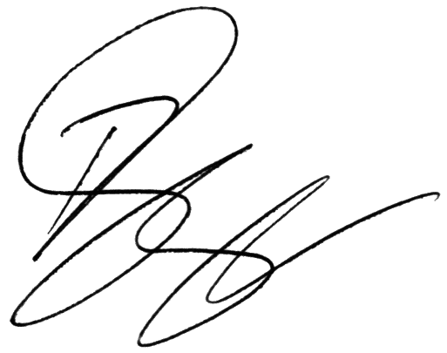
Paul Singer MVO
Official Secretary to the Governor-General

APPOINTED AN HONORARY OFFICER (AO)

IN THE MILITARY DIVISION OF THE ORDER OF AUSTRALIA

GENERAL DAVID L. GOLDFEIN United States Air Force
For distinguished service in fostering the military relationship between the United States of America and Australia through strategic vision, outstanding personal commitment, and exceptional leadership; and in recognition of his extraordinary contributions to advancing Royal Australian Air Force capability.

General Goldfein is an officer of exceptional skill and endowed with strategic vision who actively supported Australia in advancing its military capabilities. As Chief of Staff of the United States Air Force, he championed their National Defense Strategy to 'strengthen alliances and build partnerships', assisting Australia to modernise its fifth generation air power capability. He has been a staunch advocate for Australia's access to key strategic capabilities and been pivotal in opening up access to the Space domain, placing Australia as one of its key partners in the Combined Space Operations construct.

