*Excise Tariff Act 1921*

**NOTICE OF SUBSTITUTED RATES OF EXCISE DUTY**

NOTICE No. 3 (2020)

I, Tony Poulakis, delegate of the Commissioner of Taxation, in accordance with subsection 6AA and 6AAB of the *Excise Tariff Act 1921* (the Tariff Act), give notice that, on and from 1 September 2020, the substituted rate of excise duty for goods classified to each item of the Schedule to the Tariff Act set out in Column 1 of the following table is the rate set out in Column 2 opposite each item.

In this notice, “item” means item and subitem.

**THE TABLE**

|  |  |
| --- | --- |
| Column 1 | Column 2 |
|  |  |
| Excise tariff item | Substituted rate of duty |
|  |  |
| 5.1 | $1.10360 per stick |
| 5.5 | $1,576.57 per kilogram of tobacco content |
| 5.8 | The amount of duty worked out under section 6AAC |
|  |  |
|  |  |

Dated this 13th day of August 2020

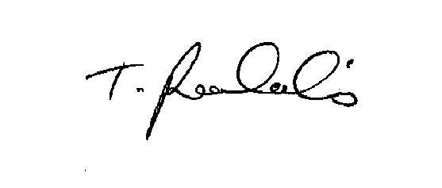

Tony Poulakis

Delegate of the Commissioner of Taxation