Government House
CANBERRA ACT 2600
4 December 2020

The Governor-General is pleased to announce the following awards:

MEDAL FOR GALLANTRY (MG)

Australian Army

Driver William Thomas DOOLAN
For acts of gallantry in action in hazardous circumstances as part of 2/21st Battalion as part of Gull Force at Kudamati village, on Ambon Island on 1 February 1942.

Corporal Sutton Henry FERRIER
For acts of gallantry in hazardous circumstances during an assault by 10th Light Horse Regiment on Hill 60 at Gallipoli, Turkey, on 29 August 1915.

Lieutenant Colonel Anthony Howard JENSEN (Retd)
For acts of gallantry in action in hazardous circumstances as the officer commanding the 1st Battalion, the Royal Australian Regiment's mortar line during the Battle for Fire Support Base Coral in Vietnam on 13 May 1968.

COMMENDATION FOR GALLANTRY

Australian Army

Private Frederick Norman SCHAEFER
For acts of gallantry in action following capture by the Imperial Japanese Army on 26 March 1945 until his execution as a result of an escape attempt on 30 April 1945.

Corporal Kenneth STEWART
For acts of gallantry in action following capture by the Imperial Japanese Army in March 1942 until his execution as a result of an escape attempt in about April 1942.

COMMENDATION FOR DISTINGUISHED SERVICE

Australian Army

Lance Corporal Harold Arthur BAILEY
For distinguished performance of duty in warlike operations as an operator on the main switchboard with Sparrow Force Headquarters on 19 and 20 February 1942.

By His Excellency’s Command

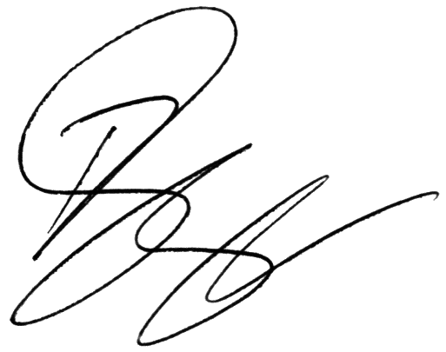
Paul Singer MVO
Official Secretary to the Governor-General

