*Excise Tariff Act 1921*

**NOTICE OF SUBSTITUTED RATES OF EXCISE DUTY**

NOTICE No. 1 (2021)

I, Tony Poulakis, delegate of the Commissioner of Taxation, in accordance with subsection 6A(9) of the *Excise Tariff Act 1921* (the Tariff Act), give notice that, on and from 1 February 2021, the substituted rate of excise duty for goods classified to each item of the Schedule to the Tariff Act set out in Column 1 of the following table is the rate set out in Column 2 opposite each item.

In this notice, “item” means item and subitem.

**THE TABLE**

|  |  |
| --- | --- |
| Column 1 | Column 2 |
|  |  |
| Excise tariff item | Substituted rate of duty |
|  |  |
| 1.1 | $ 44.45 per litre of alcohol calculated on that alcohol content by which the percentage by volume of alcohol of the goods exceeds 1.15 |
| 1.2 | $ 8.89 per litre of alcohol calculated on that alcohol content by which the percentage by volume of alcohol of the goods exceeds 1.15 |
| 1.5 | $ 51.77 per litre of alcohol calculated on that alcohol content by which the percentage by volume of alcohol of the goods exceeds 1.15 |
| 1.6 | $ 27.84 per litre of alcohol calculated on that alcohol content by which the percentage by volume of alcohol of the goods exceeds 1.15 |
| 1.10 | $ 51.77 per litre of alcohol calculated on that alcohol content by which the percentage by volume of alcohol of the goods exceeds 1.15 |
| 1.11 | $ 36.47 per litre of alcohol calculated on that alcohol content by which the percentage by volume of alcohol of the goods exceeds 1.15 |
| 1.15 | $ 3.13 per litre of alcohol calculated on that alcohol content by which the percentage by volume of alcohol of the goods exceeds 1.15 |
| 1.16 | $ 3.60 per litre of alcohol calculated on that alcohol content by which the percentage by volume of alcohol of the goods exceeds 1.15 |
| 2 | $ 87.68 per litre of alcohol |
| 3.1 | $ 81.89 per litre of alcohol |
| 3.2 | $ 87.68 per litre of alcohol |
| 3.5 | Free |
| 3.6 | Free |
| 3.7 | Free |
| 3.8 | Free |
| 3.10 | $ 87.68 per litre of alcohol |
| 10.1 | $ 0.427 per litre |
| 10.2 | $ 0.427 per litre |
| 10.3 | $ 0.427 per litre |
| 10.5 | $ 0.427 per litre |
| 10.7 | The amount of duty worked out under section 6G (using $ 0.427 at step 3 at 6G) |
| 10.10 | $ 0.427 per litre |
| 10.12 | The amount of duty worked out under section 6G (using $ 0.427 at step 3 at 6G) |
| 10.15 | $ 0.427 per litre |
| 10.16 | $ 0.427 per litre |
| 10.18 | $ 0.427 per litre |
| 10.19A | $ 0.139 per litre |
| 10.19B | $ 0.293 per kilogram |
| 10.19C | $ 0.293 per kilogram |
| 10.20 | The rate of duty is worked out under section 6H |
| 10.21 | The rate of duty is worked out under section 6J |
| 10.25 | $ 0.427 per litre |
| 10.26 | $ 0.427 per litre |
| 10.27 | $ 0.427 per litre |
| 10.28 | $ 0.427 per litre |
| 10.30 | The amount of duty worked out under section 6G (using $ 0.427 at step 3 at 6G) |

Dated this 27th day of January 2021

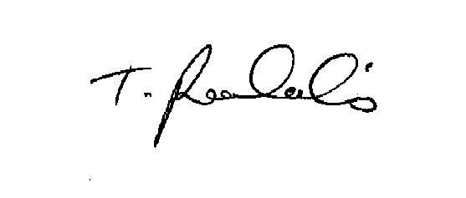

Tony Poulakis

Delegate of the Commissioner of Taxation