Government House
Canberra ACT 2600

30 March 2021
His Excellency the Governor-General directs it to be notified, for general information, that:
- He has revoked the appointments of:
- Senator the Hon Michaelia Cash as Minister for Employment, Skills, Small and Family Business;
- The Hon Peter Dutton MP as Minister for Home Affairs;
- Senator the Hon Anne Ruston as Minister for Families and Social Services;
- The Hon Karen Andrews MP as Minister for Industry, Science and Technology;
- The Hon Christian Porter MP as Attorney-General and as Minister for Industrial Relations;
- The Hon Stuart Robert MP as Minister for the National Disability Insurance Scheme and Minister for Government Services;
- Senator the Hon Linda Reynolds CSC as Minister for Defence;
- The Hon Melissa Price MP as Minister for Defence Industry;
- Senator the Hon Jane Hume as Minister for Superannuation, Financial Services and the Digital Economy; and
- Senator the Hon Amanda Stoker as Parliamentary Secretary to the Attorney-General.

- He has made the following appointments:

- Senator the Hon Michaelia Cash as Attorney-General and as Minister for Industrial Relations;
- The Hon Peter Dutton MP as Minister for Defence;
- Senator the Hon Anne Ruston as Minister for Families and Social Services and as Minister for Women’s Safety;
- The Hon Karen Andrews MP as Minister for Home Affairs;
- The Hon Christian Porter MP as Minister for Industry, Science and Technology;
- The Hon Stuart Robert MP as Minister for Employment, Workforce, Skills, Small and Family Business;
- Senator the Hon Linda Reynolds CSC as Minister for Government Services and as Minister for the National Disability Insurance Scheme;
- The Hon Melissa Price MP as Minister for Defence Industry;
- Senator the Hon Jane Hume as Minister for Superannuation, Financial Services and the Digital Economy, and as Minister for Women’s Economic Security;
- Senator the Hon Amanda Stoker as Parliamentary Secretary to the Attorney-General, as Parliamentary Secretary to the Minister for Industrial Relations, and as Parliamentary Secretary to the Minister for Women;
- The Hon Ben Morton MP to administer the Department of Home Affairs; and
- The Hon Michelle Landry MP to administer the Department of the Prime Minister and Cabinet.

By His Excellency’s Command
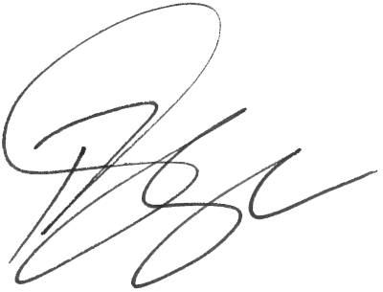
Paul Singer MVO
Official Secretary to the Governor-General

