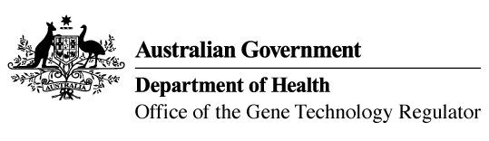 11 May 2021

Invitation to comment on a clinical trial with a genetically modified E.coli to reduce antibiotic resistance
The Gene Technology Regulator is assessing an application from The Westmead Institute for Medical Research to conduct a clinical trial, under limited and controlled conditions. The trial involves the use of genetically modified probiotic E.coli to reduce antibiotic resistance within the gastro-intestinal tract of the trial participants. The trial is proposed to take place at the Westmead Hospital with up to 100 trial participants over a period of five years.
The Regulator has prepared a Risk Assessment and Risk Management Plan (RARMP) for this application and welcomes written submissions on issues relating to the protection of human health and safety and the environment prior to making a decision on whether or not to issue the licence. The consultation RARMP and related information can be obtained via the contacts below. Submissions should reference DIR 183 and be received by 15 June 2021.
Office of the Gene Technology Regulator
MDP 54 GPO Box 9848 CANBERRA ACT 2601
Telephone: 1800 181 030 Website: www.ogtr.gov.au
E-mail: ogtr@health.gov.au

