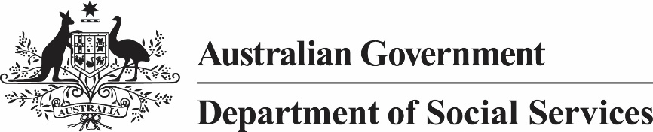

*Child Support (Assessment) Act 1989*

Notice under subsection 155(2A)

I, Kathryn Campbell, Secretary of the Department of Social Services, give notice under subsection 155(2A) of the *Child Support (Assessment) Act 1989* that the AWE amount (see section 58AA of that Act) for the quarter ending on 31 December 2020 is $1,291.30.

[signed]

Kathryn Campbell AO CSC

Secretary

11 June 2021