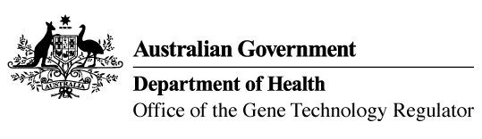
24 June 2021

Invitation to comment on the commercial release
of a genetically modified canola
The Gene Technology Regulator is assessing an application from BASF Australia Ltd for commercial cultivation of canola genetically modified (GM) for herbicide tolerance and a hybrid breeding system in all canola growing areas of Australia. The GM canola lines and their products would enter general commerce, including use in human food and animal feed.
The Regulator has prepared a Risk Assessment and Risk Management Plan (RARMP) for this application and welcomes written submissions on issues relating to the protection of human health and safety and the environment prior to making a decision on whether or not to issue the licence. The consultation RARMP and related information can be obtained via the contacts below. Submissions should reference DIR 178 and be received by 12 August 2021.

Office of the Gene Technology Regulator, MDP 54, GPO BOX 9848 CANBERRA ACT 2601
Telephone: 1800 181 030 Website: www.ogtr.gov.au
E-mail: ogtr@health.gov.au

