National Radioactive Waste Management—Notice to persons with rights or interests 2021

**‘NAPANDEE’**

1. This notice is published pursuant to section 18(1)(b) of the *National Radioactive Waste Management Act 2012* (***the Act***).
2. For the purposes of subsection 14(2) of the Act, I, the Hon Keith Pitt, Minister for Resources and Water, propose to declare, that:
3. The land bounded by the line starting at the point described in item 1 of the following table and running sequentially as described in the table (the selected site), being part of the land nominated as a site under section 7 of the Act and approved by the Minister as a site under section 9 of the Act as set out in schedule 1, subitem 1(1) table item 1, of the *National Radioactive Waste Management Amendment (Site Specification, Community Fund and Other Measures) Act 2021* (referred to as ‘Napandee’), is selected as the site for a facility under section 14(2) of the Act;

| **Item** | **Description** |
| --- | --- |
| 1 | The point that is at a bearing of 270°52′40″ along the Tola Road boundary, and 25 metres west from the south-east corner, of the land described in South Australian Certificate of Title Volume 5937 Folio 542, being Section 94, Hundred of Pinkawillinie, in the area named Pinkawillinie |
| 2 | Bearing 270°52′40″ for 581.80 metres |
| 3 | Bearing 270°53′10″ for 727.75 metres |
| 4 | Bearing 309°36′10″ for 122.73 metres |
| 5 | Bearing 0°35′40″ for 1440.36 metres |
| 6 | Bearing 91°53′40″ for 1408.72 metres |
| 7 | Bearing 180°44′40″ for 839.72 metres |
| 8 | Bearing 202°39′00″ for 138.70 metres |
| 9 | Bearing 179°30′00″ for 53.60 metres |
| 10 | Bearing 164°32′10″ for 69.21 metres |
| 11 | Bearing 154°10′50″ for 70.06 metres |
| 12 | Bearing 180°44′40″ for 341.08 metres to the starting point |

1. all rights and interests in the selected site are specified for the purposes of section 14(2) of the Act; and
2. in accordance with section 16(1) of the Act, the proposed declaration will take effect at the time the declaration is made.
3. For illustrative purposes, a map showing the selected site is shown attached.
4. Persons with a right or interest in the land are invited to comment on the declaration proposed in paragraph 2 of this notice by 22 October 2021. Comments can be made at **https://consult.industry.gov.au/arwa/nrwmf-site-declaration** or by post to Australian Radioactive Waste Agency, GPO Box 2013, Canberra ACT 2601.
5. When providing comments, please include (without limitation) the following information:
   1. *Name and contact details*
   2. *Details of your right or interest in the land*
   3. *Comments on the proposed declaration*

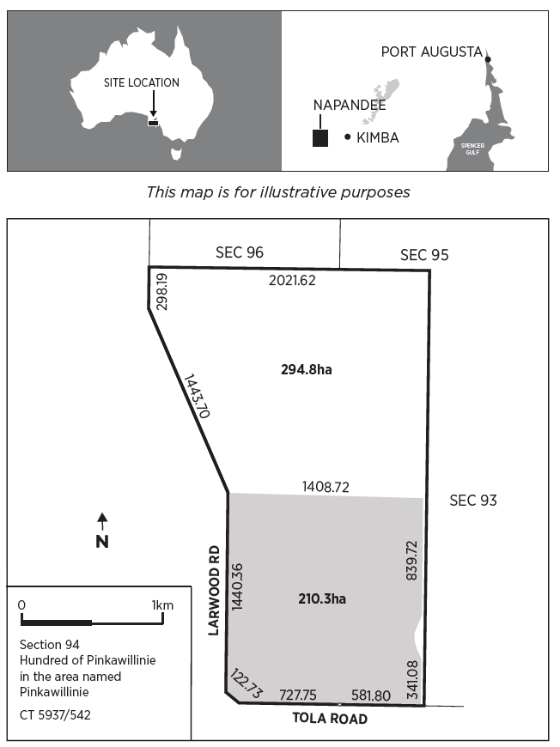*Napandee site selection site location*