Aboriginal and Torres Strait Islander Heritage Protection Act 1984 (Cth)
Notice of an application for the protection of a specified area, consisting of six parts, near and overlapping Wahluu / Mount Panorama, Bathurst, NSW
Invitation to make representations
I, Elle Lillis, hereby give notice as follows:
The Minister for the Environment (Minister), responsible for the Aboriginal and Torres Strait Islander Heritage Protection Act 1984 (Cth) (Act), has received an application made under section 10 of the Act. The application is seeking long term preservation and protection of a claimed significant Aboriginal area, consisting of six parts, near and overlapping, Wahluu / Mount Panorama, Bathurst, New South Wales. The Minister has appointed me to provide a report to the Minister under paragraph 10(1)(c) of the Act.

The Applicant
The application is made by the Wiradyuri Traditional Owners Central West Aboriginal Corporation (applicant).

The purpose of the application
The application seeks the long-term preservation or protection of the area specified in the application (specified area). The specified area is depicted in Figure 1 below. Section 10 of the Act confers power on the Minister to make a declaration to preserve and protect an area where the Minister is satisfied that it is a ‘significant Aboriginal area’ under threat of injury or desecration. A ‘significant Aboriginal area’ is defined by section 3 of the Act as an area of land or waters that is “of particular significance to Aboriginals in accordance with Aboriginal tradition”. ‘Aboriginal tradition’ is defined as the “body of traditions, observances, customs and beliefs of Aboriginals generally or of a particular community or group of Aboriginals, and includes any such traditions, observances, customs or beliefs relating to particular persons, areas, objects or relationships”.

Matters the report is required to deal with
The Minister must consider my report pursuant to section 10 of the Act in relation to the specified area before deciding whether to make a declaration under section 10 of the Act. Under subsection 10(4) of the Act, the report is required to deal with the following matters:
- the particular significance of the area to Aboriginals;
- the nature and extent of the threat of injury to, or desecration of, the area;
- the extent of the area that should be protected;
- the prohibitions and restrictions to be made with respect to the area;
- the effects the making of a declaration may have on the proprietary or pecuniary interests of persons other than the Aboriginal or Aboriginals who made the application, or on whose behalf the application is made;
- the duration of any declaration;
- the extent to which the area is or may be protected by or under a law of the State or Territory, and the effectiveness of any remedies available under any such law; and
- such other matters (if any) as prescribed.

The specified area
Figure 1 below depicts the specified area, consisting of six parts, near and overlapping Wahluu / Mount Panorama for which preservation and protection is sought.
Figure 1 Map showing the specified area, consisting of six parts, near and overlapping Wahluu / Mount Panorama.
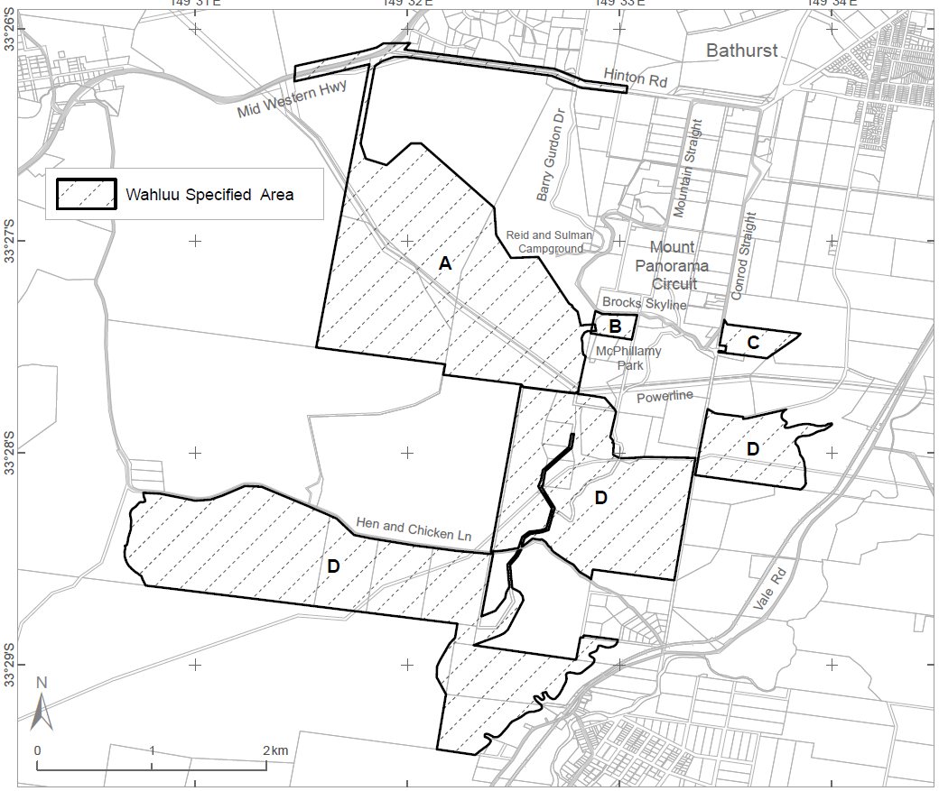

Claims in relation to ‘significant Aboriginal area’
The applicant claims the specified area is of particular significance in accordance with Aboriginal tradition for the following reasons:
- The applicant has knowledge that Wahluu, including the specified area, is a cultural landscape with deep cultural significance that includes a complex of sacred places and significant cultural items associated with specific cultural purposes.
- The applicant has knowledge that the specified area has both tangible and intangible heritage values, including archaeological evidence.
- The applicant has knowledge that the specified area is sacred and associated with their cultural knowledge and stories.

Claimed threat of injury or desecration
The applicant claims the specified area is under threat from:
- The construction of a second motor vehicle racing circuit, and associated facilities near, and overlapping parts of, Wahluu / Mount Panorama. The second circuit is proposed by Bathurst Regional Council (proponent 1). Refer to Figure 1, the specified area labelled A;
- Circuit maintenance and preparation, including earthworks and removal of rocks at Mount Panorama Motorcycle Club Mount Panorama Motocross Circuit, proposed by Panorama Motorcycle Club Inc (proponent 2). Refer to Figure 1, the specified area labelled A;
- Remediation works at McPhillamy Park, proposed by Bathurst Regional Council. Refer to Figure 1, the specified area labelled B;
- The construction of a dwelling at 428 Conrad Straight, proposed by Botham Homes (proponent 3). Refer to Figure 1, the specified area labelled C; and
- Geotechnical test pits and bore holes for construction of a pipeline, proposed by GHD Pty Ltd (proponent 4). Refer to Figure 1, the specified area labelled D.

Invitation to make representations
Interested parties are invited to furnish representations in connection with my report to:
Elle Lillis
Principal Archaeologist, Virtus Heritage
PO Box 101,
Pottsville NSW 2489
Phone: (02) 6676 4354
Email: consultation@virtusheritage.com.au
Interested parties are urged to contact me as soon as possible to be provided with further information about the submission process, including the provision of the application, making representations in response to the application, and making final comments in response to representations received.
Representations must be made in writing by 5pm on Monday 6 December 2021, or within such further period as may be allowed. Do not send your representations directly to the Minister.
Representations received by the due date will subsequently be provided to the applicant and to all interested parties who submitted a representation, and thereafter the applicant and interested parties will be afforded an additional period of two weeks to make final comments in writing.

Claiming confidentiality
If you wish to claim confidentiality over any part of your representation, please identify why you are claiming confidentiality and how you wish confidentiality to apply. Representations will be provided to the Minister for the Environment and the Department of Agriculture, Water and the Environment, along with the section 10 report. Representations, even those subject to confidentiality, may be disclosed where it is authorised or required by law, to meet procedural fairness requirements, and in response to a request by a House or Committee of the Parliament of the Commonwealth.

Privacy notice
Personal information means information or an opinion about an identified individual, or an individual who is reasonably identifiable.
Sensitive information is a subset of personal information and includes any information or opinion about an individual's racial or ethnic origin, political opinion or association, religious beliefs or affiliations, philosophical beliefs, sexual preferences or practices, trade or professional associations and memberships, union membership, criminal record, health or genetic information and biometric information or templates.
By submitting a representation in response to the ‘Notice of an application for the preservation and protection of a specified area, consisting of six parts, near and overlapping Wahluu / Mount Panorama, Bathurst, NSW’, you consent to the collection of all personal information, including sensitive information, contained in your representation.
I, Elle Lillis, collect your personal information (as defined by the Privacy Act 1988 (Cth)) contained in your representation for the purposes of consideration in drafting a report under section 10 of the Aboriginal and Torres Strait Islander Heritage Protection Act 1984 (Cth) (Act) in relation the specified area and related purposes. If you do not provide some or all of any relevant personal information in your representation(s), I may be unable to fully and comprehensively consider your representation in the drafting of the report to be submitted for consideration by the Minister responsible for the Department of Agriculture, Water and the Environment (Minister).
The Department of Agriculture, Water and the Environment (department) collects your personal information (as defined by the Privacy Act 1988 (Cth)) contained in your representation for the purposes of the Minister’s consideration in deciding whether to make a declaration under section 10 of the Act in relation to the specified area and related purposes. If you do not provide some or all of any relevant personal information in your representation(s), the Minister may be unable to fully and comprehensively consider your representation in deciding whether to make a declaration under section 10 of the Act in relation to the specified area.
The department may disclose your personal information to the Minister, parties that may be affected by a decision of the Minister under section 10 of the Act (to meet procedural fairness requirements), and other Australian government agencies, persons or organisations where necessary for the above purposes, provided the disclosure is consistent with relevant laws, in particular the Privacy Act 1988 (Cth). Your personal information will be used and stored in accordance with the Australian Privacy Principles.
By submitting a representation, you consent to the disclosure of all personal information contained in your representation to the Minister and parties that may be affected by the decision of the Minister under section 10 of the Act.
See the department's Privacy Policy to learn more about accessing or correcting personal information or making a complaint. Alternatively, telephone the department on +61 2 6272 3933.

