

**Government House**

**CANBERRA ACT 2600**

**9 August 2021**

The Governor-General is pleased to announce the following honorary appointment in the Order of Australia:

**HONORARY COMPANION (AC) IN THE GENERAL DIVISION**

**General James MATTIS (Retd)** United States of America

For eminent service to Australia's bilateral relationship with

the United States of America, and to enhancing international security.

**By His Excellency’s Command**

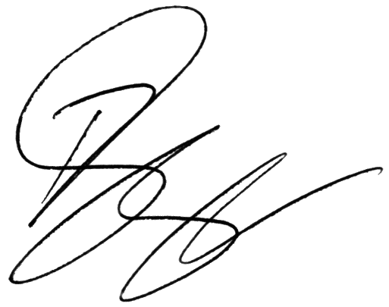

**Paul Singer MVO**

Official Secretary to the Governor-General