***Aboriginal and Torres Strait Islander Heritage Protection Act 1984* (Cth)**

Notice of an application for the protection of a specified area, being an area at Sandy Bore, APY Lands, South Australia

**Invitation to make representations**

I, Andrew Cawthorn, hereby give notice as follows:

The Minister for the Environment, responsible for the *Aboriginal and Torres Strait Islander Heritage Protection Act 1984* (Cth)(the **Act**), has received an application made under section 10 of the Act. The Minister has appointed me to provide a report to the Minister under paragraph 10(1)(c) of the Act.

**The Applicant**

The application is made by Mr Rex Tjami, a Yankunytjatjara Traditional Owner, legally represented by

Ms Rosanne McInnes.

**The purpose of the application**

The Applicant seeks the long-term preservation and protection of an area specified in their application. This specified area (**specified area**) is depicted in Figure 1 below. Section 10 of the Act confers power on the Minister to make a declaration to preserve and protect an area where the Minister is satisfied that it is a ‘significant Aboriginal area’ under threat of injury or desecration. A ‘significant Aboriginal area’ is defined by section 3 of the Act as an area of land or waters that is “of particular significance to Aboriginals in accordance with Aboriginal tradition”. ‘Aboriginal tradition’ is defined as the “body of traditions, observances, customs and beliefs of Aboriginals generally or of a particular community or group of Aboriginals, and includes any such traditions, observances, customs or beliefs relating to particular persons, areas, objects or relationships”.

### Matters the report is required to deal with

The Minister will consider my report pursuant to section 10 of the Act in relation to the specified area before deciding whether to make a declaration under section 10 of the Act. Under subsection 10(4) of the Act, the report is required to deal with the following matters:

1. the particular significance of the area to Aboriginal peoples;
2. the nature and extent of the threat of injury to, or desecration of, the area;
3. the extent of the area that should be protected;
4. the prohibitions and restrictions to be made with respect to the area;
5. the effects the making of a declaration may have on the proprietary or pecuniary interests of persons other than the Aboriginal or Aboriginals on whose behalf the application is made;
6. the duration of any declaration;
7. the extent to which the area is or may be protected by or under a law of the State or Territory, and the effectiveness of any remedies available under any such law; and
8. such other matters (if any) as prescribed.

### The specified area

**Figure 1 – Map of the specified area at Sandy Bore, APY Lands, South Australia.**

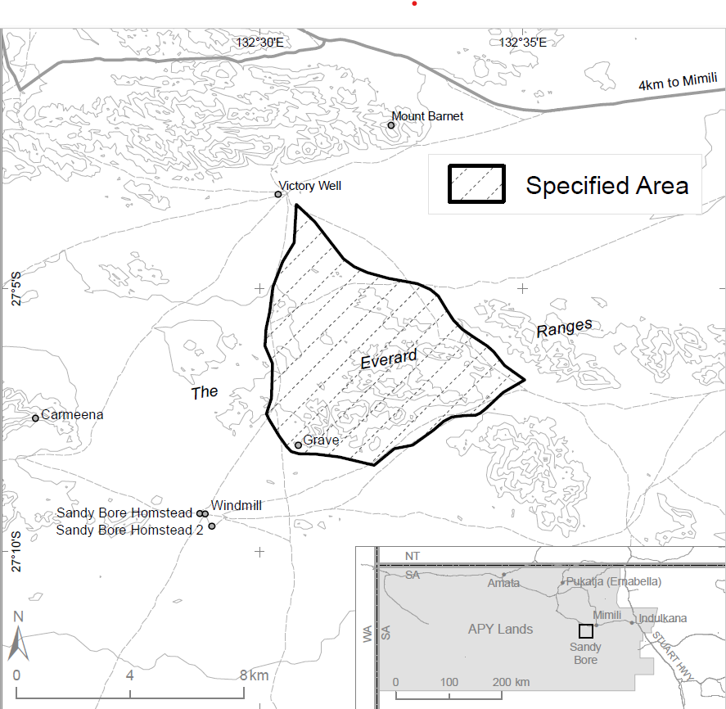

The applicant seeks protection of the area depicted in Figure 1 above (**the** **specified area**).

The initial application sought emergency protection of the specified area under sections 9 and 18 of the Act, being caves where a child lived and was buried, and protection of an object under section 12. The applicant subsequently withdrew the applications under sections 9 and 18, and made an application under section 10 of the Act on 20 August 2021, noting the threat is ongoing and long-term protection was being sought.

**Nature of ‘particular significance’**

The application claims the specified area is of particular significance in accordance with Aboriginal tradition for the following reasons:

* A child is traditionally buried in one of the caves in the area. This child has been identified as a relative of a Yankunytjatjara traditional owner. The story of the child and its family has been passed down through oral histories.
* Stones and handmade objects buried with the child recorded the child’s connections with people and Country.
* The area is also part of a song line, associated with the Minyama Kutjara-ku Tjukurpa (The Two Sisters’) dreaming.

**Threat of injury or desecration**

In 2016, APY Land Management found old remains of a traditionally buried child in a cave whilst managing the Sandy Bore Indigenous Protected Area (IPA). APY Land Management complied with their duty to report the find to Mimili police, who reported to senior policy officers in Port Augusta. Under the directions of the Adelaide Forensic Science Unit and assisted by Mimili police, a Port Augusta police officer seized the child’s remains for the South Australian coroner before the Traditional Owners could be identified and consulted.

On 5 April 2018, the remains were returned to Country and reburied. The remains were returned from forensic examination in a state which precluded traditional reburial. After the reburial, the remains, the cave where the remains have been reburied, and a 10 metre radius surrounding the cave, were listed on the Aboriginal Affairs and Reconciliation’s (AAR) central archives under section 23 of the *Aboriginal Heritage Act 1988* (SA).

The applicant has expressed doubt as to whether being recorded in the AAR archives offers adequate protection. Additionally, the larger area associated with the life of the child and the dreaming is not registered in the archive and is not considered protected.

The applicant has noted that there is an ongoing threat of the area being treated in a manner inconsistent with Aboriginal tradition when the site is accessed for any reason, including for recreational rock climbing, and scientific research. Consent for research to be conducted on the remains whilst under the care of the Coroner in Adelaide was previously given in an attempt to preclude the remains becoming the subject of scientific investigation post repatriation.

The applicant has expressed concerns that, given the existence and location of the remains being known, Traditional Owners cannot prevent the remains being disturbed by other persons under State law, including persons conducting research on the remains.

The applicant has noted past police and coroner interference with the site, and has claimed past failures to identify or consult with Traditional Owners, the landowner (APY), or anthropologists employed by APY.

### Invitation to make representations

Interested persons (or parties) are invited to furnish representations in connection with my report to:

Andrew Cawthorn  
Consultant, Cawthorn Consulting   
PO Box 218, Uraidla SA 5142

Ph: +61 401 608 510

Email: andrewcawthorn@protonmail.com

Interested parties are urged to **contact me** as soon as possible to be provided with further information about the submission process, including the provision of the Application, then the making representations in response to the Application, followed by the making final comments in response to representations received.

As part of the submission process, I will seek to take oral submissions from the Applicant, and if such occurs, any arising written record I make will be supplied to the other interested parties as a representation.

Representations must be made in writing by **5pm** (Australian Eastern Standard Time) on **Sunday 16 January 2022**, or within such further period as may be allowed. **Do not send your representations directly to the Minister**.

Representations received by the due date will subsequently be provided to the Applicant and to all interested parties who duly submitted a representation, and thereafter the Applicant and such interested parties will be afforded an additional period of three weeks to make final comments in writing.

**Claiming confidentiality**

If you wish to claim confidentiality over any part of your submission, please identify why you are claiming confidentiality and how you wish confidentiality to apply. Representations, final comments, plus all correspondence received and sent by me, will be provided to the Minister for the Environment, along with my report. Representations, final comments, and correspondence, even those subject to confidentiality, may be disclosed where it is authorised or required by law, to meet procedural fairness requirements, and in response to a request by a House or Committee of the Parliament of the Commonwealth.

**Privacy notice**

Personal information means information or an opinion about an identified individual, or an individual who is reasonably identifiable.

Sensitive information is a subset of personal information and includes any information or opinion about an individual's racial or ethnic origin, political opinion or association, religious beliefs or affiliations, philosophical beliefs, sexual preferences or practices, trade or professional associations and memberships, union membership, criminal record, health or genetic information and biometric information or templates.  
  
By submitting a representation in response to the ‘Notice of an application for the preservation and protection of a specified area, being Sandy Bore, APY Lands, South Australia’ you consent to the collection of all personal information, including sensitive information, contained in your representation.

I, Andrew Cawthorn, collect your personal information (as defined by the *Privacy Act 1988*) contained in your representation for the purposes of consideration in drafting a report under section 10 of the Act in relation the specified area and related purposes. If you do not provide some or all of any relevant personal information in your representation(s), I may be unable to fully and comprehensively consider your representation in the drafting of the report to be submitted for the Minister’s consideration.

Department of Agriculture, Water and the Environment (the **department**) collects your personal information (as defined by the *Privacy Act 1988*) contained in your representation for the purposes of the Minister’s consideration in deciding whether to make a declaration under section 10 of the Act in relation to the specified area and related purposes. If you do not provide some or all of any relevant personal information in your representation(s), the Minister may be unable to fully and comprehensively consider your representation in deciding whether to make a declaration under section 10 of the Act in relation to the specified area.

The department may disclose your personal information to the Minister, parties that may be adversely affected by a decision of the Minister under section 10 of the Act (to meet procedural fairness requirements), and other Australian government agencies, persons or organisations where necessary for the above purposes, provided the disclosure is consistent with relevant laws, in particular the *Privacy Act 1988*. Your personal information will be used and stored in accordance with the Australian Privacy Principles.

By submitting a representation you consent to the disclosure of all personal information contained in your representation to the Minister and parties that may be adversely effected by the decision of the Minister under section 10 of the Act.

See the department's [Privacy Policy](https://www.awe.gov.au/about/commitment/privacy) to learn more about accessing or correcting personal information or making a complaint. Alternatively, telephone the department on +61 2 627**2 3933.**