Aboriginal and Torres Strait Islander Heritage Protection Act 1984 (Cth)
Notice of an application for the protection of a specified area, being an area at Robbins Island, Tasmania, Australia
Invitation to make representations
I, Vanessa Edmonds, hereby give notice as follows:
The Minister for the Environment (Minister), responsible for the Aboriginal and Torres Strait Islander Heritage Protection Act 1984 (Cth) (Act), has received an application made under section 10 of the Act. The Minister has appointed me to provide a report to the Minister under paragraph 10(1)(c) of the Act.

The Applicant
The application is made by Mr Malcolm Stokes (Applicant), a representative on behalf of the Tasmanian Aboriginal people.

The purpose of the application
The Applicant seeks the long-term preservation and protection of an area specified in their application. This specified area (specified area) is depicted in Figure 1 below. Section 10 of the Act confers power on the Minister to make a declaration to preserve and protect an area where the Minister is satisfied that it is a ‘significant Aboriginal area’ under threat of injury or desecration. A ‘significant Aboriginal area’ is defined by section 3 of the Act as an area of land or waters that is “of particular significance to Aboriginals in accordance with Aboriginal tradition”. ‘Aboriginal tradition’ is defined as the “body of traditions, observances, customs and beliefs of Aboriginals generally or of a particular community or group of Aboriginals, and includes any such traditions, observances, customs or beliefs relating to particular persons, areas, objects or relationships”.

Matters the report is required to deal with
The Minister will consider my report pursuant to section 10 of the Act in relation to the specified area before deciding whether to make a declaration under section 10 of the Act. Under subsection 10(4) of the Act, the report is required to deal with the following eight matters:
- the particular significance of the area to Aboriginal peoples;
- the nature and extent of the threat of injury to, or desecration of, the area;
- the extent of the area that should be protected;
- the prohibitions and restrictions to be made with respect to the area;
- the effects the making of a declaration may have on the proprietary or pecuniary interests of persons other than the Aboriginal or Aboriginals on whose behalf the application is made;
- the duration of any declaration;
- the extent to which the area is or may be protected by or under a law of the State or Territory, and the effectiveness of any remedies available under any such law; and
- such other matters (if any) as prescribed.

The specified area
Figure 1 below depicts the area for which preservation and protection is sought. The specified area is Robbins Island, Boullanger Bay wetlands and Robbins Passage, North-west Tasmania, between Stanley and Smithton. It is privately owned and is used primarily for cattle grazing. It is separated from the mainland by the shallow tidal Robbins Passage and Boullanger Bay. For the purposes of this Notice, the specified area will be referred to as ‘being an area at Robbins Island, Tasmania, Australia’.

Figure 1 – Map showing the specified area, being an area at Robbins Island, Tasmania, Australia.

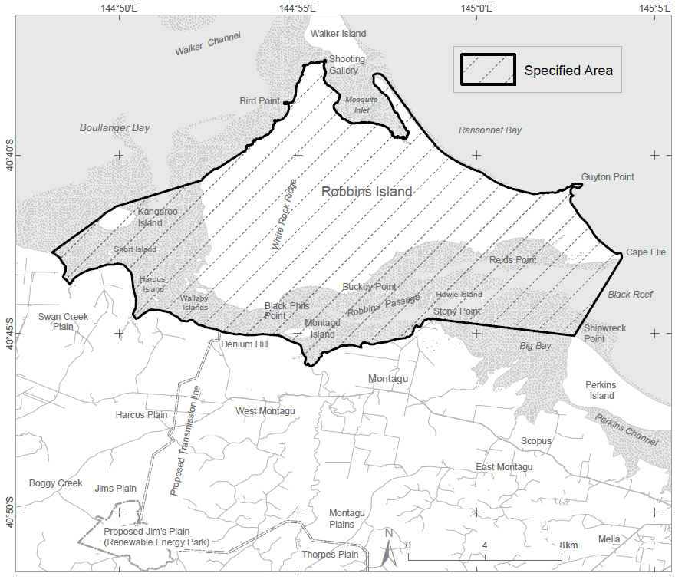

Nature of ‘particular significance’

The Applicant claims that the specified area is of particular significance in accordance with Aboriginal tradition for several reasons, including:
- As the birthplace of Tunnerminnerwait who is significant to Aboriginal people because of his history on Robbins Island and his first contact connections.

- As one of the best sites on the north-west coast for Bush Tucker ranging from the Shearwater (mutton birds), bird eggs, salt bush, pepper berry and pig face.

- As a fishing area and a fish nursery for many species. Fish were caught with fish traps and with spears. These methods are still being passed down and used today.

- Many areas on Robbins lsland hold tangible Tasmanian Aboriginal cultural values still evident today. These include rock shelters, camp and midden sites, seal hides, rock tools of various different materials, ochre and songlines.

- Robbins lsland also holds many intangible cultural values which used to be taught and handed down to younger generations. These include birding, hunting, gathering, and fishing practises has been handed down for generations. Elders would meet on Robbins lsland to conduct cultural practises and under healing.

Claimed threat of injury or desecration
The Applicant claims that the specified area is under threat from a project proposed by UPC Renewables Australia to place a Renewable Energy Park on the island. The proposed project entails construction of up to 122 turbines (270 metres tall with concrete bases), a new bridge to link the island to the foreshore, a new port and energy transmission line infrastructure and roads. The Applicant claims that the project will cause loss, desecration of, and harm to Aboriginal heritage. The applicant further states that UPC/AC Renewables solution to place artefacts found during construction in a new museum near Robbins Island will not protect, rather further desecrate objects of sacred nature by removing them off Country.

Invitation to make representations
Interested persons (or parties) are invited to furnish representations in connection with my report to:
Vanessa Edmonds
Principal, Everick Heritage Pty Ltd
6B Reserve Street, Annandale NSW 2038
Ph: +61 429 114 188
Email: v.edmonds@everick.net.au
Interested parties are urged to contact me as soon as possible to be provided with further information about the submission process, including the provision of the Application, then the making representations in response to the Application, followed by the making final comments in response to representations received.
As part of the submission process, I will seek to take oral submissions from the Applicant, and if such occurs, any arising written record I make will be supplied to the other interested parties as a representation.
Representations must be made in writing by 5pm AEST on Sunday 16 January 2022, or within such further period as may be allowed. Do not send your representations directly to the Minister.
Representations received by the due date will subsequently be provided to the Applicant and to all interested parties who duly submitted a representation, and thereafter the Applicant and such interested parties will be afforded an additional period of three weeks to make final comments in writing.

Claiming confidentiality
If you wish to claim confidentiality over any part of your submission, please identify why you are claiming confidentiality and how you wish confidentiality to apply. Representations, final comments, plus all correspondence received and sent by me, will be provided to the Minister for the Environment, along with the section 10 report. Representations, final comments, and correspondence, even those subject to confidentiality, may be disclosed where it is authorised or required by law, to meet procedural fairness requirements, and in response to a request by a House or Committee of the Parliament of the Commonwealth.
Privacy notice
Personal information means information or an opinion about an identified individual, or an individual who is reasonably identifiable.
Sensitive information is a subset of personal information and includes any information or opinion about an individual's racial or ethnic origin, political opinion or association, religious beliefs or affiliations, philosophical beliefs, sexual preferences or practices, trade or professional associations and memberships, union membership, criminal record, health or genetic information and biometric information or templates.
By submitting a representation in response to the ‘Notice of an application for the preservation and protection of a specified area, being Robbins Island, Tasmania’, you consent to the collection of all personal information, including sensitive information, contained in your representation.
I, Vanessa Edmonds, collect your personal information (as defined by the Privacy Act 1988) contained in your representation for the purposes of consideration in drafting a report under section 10 of the Act in relation the specified area and related purposes. If you do not provide some or all of any relevant personal information in your representation(s), I may be unable to fully and comprehensively consider your representation in the drafting of the report to be submitted for the Minister’s consideration.
The Department of Agriculture, Water and the Environment (department) collects your personal information (as defined by the Privacy Act 1988) contained in your representation for the purposes of the Minister’s consideration in deciding whether to make a declaration under section 10 of the Act in relation to the specified area and related purposes. If you do not provide some or all of any relevant personal information in your representation(s), the Minister may be unable to fully and comprehensively consider your representation in deciding whether to make a declaration under section 10 of the Act in relation to the specified area.
The department may disclose your personal information to the Minister, parties that may be adversely affected by a decision of the Minister under section 10 of the Act (to meet procedural fairness requirements), and other Australian government agencies, persons or organisations where necessary for the above purposes, provided the disclosure is consistent with relevant laws, in particular the Privacy Act 1988. Your personal information will be used and stored in accordance with the Australian Privacy Principles.
By submitting a representation, you consent to the disclosure of all personal information contained in your representation to the Minister and parties that may be adversely affected by the decision of the Minister under section 10 of the Act.
See the department's Privacy Policy to learn more about accessing or correcting personal information or making a complaint. Alternatively, telephone the department on +61 2 6272 3933.

