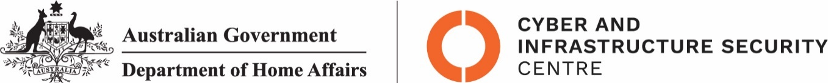

NTC-22069

***Aviation Transport Security Act 2004***

**NTC-22069 – DECLARATION OF SECURITY CONTROLLED AIRPORT AND ESTABLISHMENT OF AIRSIDE AREA – TOWNSVILLE AIRPORT**

I am a Delegate of the Secretary of the Department of Home Affairs. Under subsection 28(2) of the

*Aviation Transport Security Act 2004* (the Act), I:

**REVOKE** notice NTC-13140 which declared Townsville Airport as a security controlled airport as

published in the *Gazette (C2017G00494, 4 May 2017)*; and

**DECLARE** Townsville Airport is a security controlled airport, the boundaries of Townsville Airport are

shown on the attached map which forms part of this notice; and

**ESTABLISH,** in accordance with section 29 of the Act, an airside area for Townsville Airport being

that area indicated as the airside area on the attached map which forms part of this notice.

This Notice commences upon publication in the *Gazette*.

Jaran Blethyn

Assistant Director, Regulatory Compliance

Cyber and Infrastructure Security Operations

Delegate of the Secretary of the

Department of Home Affairs

15 December 2021

Note:

1. *Gazette* means the *Commonwealth of Australia Gazette*
2. This Notice remains in force until otherwise revoked in writing and upon subsequent publication in the *Gazette*

NTC-22069

