Government House

CANBERRA ACT 2600

27 January 2022

Honorary Appointment and Awards - January 2022

The Governor-General is pleased to announce the following appointment and awards:

HONORARY COMPANION (AC) IN THE GENERAL DIVISION

Sir Barry Alan GIBB CBE
United States of America
For eminent service to the performing arts as a musician, songwriter and record producer, to the advancement of Australian music artists, and to philanthropy.

HONORARY MEDAL (OAM) IN THE GENERAL DIVISION

Mr Barry Keith BARNES
United Kingdom
For service to commemorating the service of Australian Flying Corps in Tetbury, England, and surrounding areas, during World War One.

Mr Gilbert Arthur BROGDEN
Narrabeen NSW 2101
For service to the community, particularly through volunteering and fundraising for local and national charity organisations.

Mrs Shirley Joan CONNOLLY
Grasmere NSW 2570
For service to netball, particularly in the Macarthur region of New South Wales.

Mrs Christine Robin FORSYTH
Laguna NSW 2325
For service to the Wollombi Valley region, particularly through sporting, arts and community organisations.

Mr Wayne Jude LINDSAY
Boronia Heights QLD 4124
For service to the Australian and New Zealand veterans community.

By His Excellency’s command

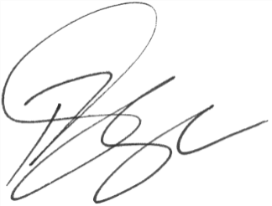

Paul Singer MVO
Official Secretary to the Governor-General

