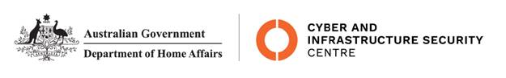

NTC-22247

***Aviation Transport Security Act 2004***

**NTC-22247 - DECLARATION OF SECURITY CONTROLLED AIRPORT AND ESTABLISHMENT OF AIRSIDE AREA – BROOME INTERNATIONAL AIRPORT**

I am a Delegate of the Secretary of the Department of Home Affairs (Secretary). Under subsection

28(2) of the *Aviation Transport Security Act 2004* (the Act), I:

**REVOKE** notice NTC-21824 which declared Broome International Airport as a security controlled airport published in the *Gazette* (*C2021G00837 on 4 November 2021*); and

**DECLARE** that Broome International Airport is a security controlled airport, the boundaries of Broome International Airport are shown on the attached maps which form part of this notice; and

**ESTABLISH,** in accordance with section 29 of the Act, an airside area for Broome International Airport being that area indicated as the airside area on the attached maps which form part of this notice.

This Notice commences upon publication in the *Gazette*.

Jaran Blethyn

Assistant Director, Regulatory Compliance

Cyber and Infrastructure Security Operations

Delegate of the Secretary of the

Department of Home Affairs

25 January 2022

Note:

1. *Gazette* means the *Commonwealth of Australia Gazette*
2. This Notice remains in force until otherwise revoked in writing and upon subsequent publication in the *Gazette*

