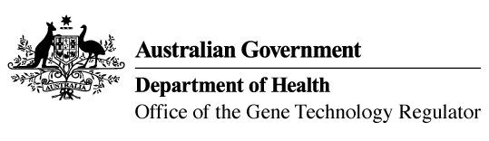

Invitation to comment on a proposal to include dealings with GM canola on the GMO Register

The Gene Technology Regulator has initiated a process to consider including dealings with MON-ØØØ73-7 (also known as Roundup Ready®) canola genetically modified for herbicide tolerance on the GMO Register. The dealings have been authorised under licence DIR 020/2002 since 2003.
Inclusion on the GMO Register occurs by way of legislative instrument made by the Regulator under section 78 of the Gene Technology Act 2000. The Regulator must be satisfied that any risks posed by the dealings are minimal and that they can be safely undertaken by anyone without the need for a licence. There have been no reports of adverse effects on human health and safety, or the environment resulting from the dealings licensed under DIR 020/2002.
A consultation version of the risk assessment and risk management plan (RARMP) has been prepared. It provides a science-based evaluation and concludes that the dealings with the GM canola pose minimal risk to people or the environment. The consultation RARMP and related information can be obtained via the contacts below.
The Regulator invites written submissions on matters relevant to risks to human health and safety and the environment that may be posed by the dealings with the GM canola. Submissions should reference Reg-003 and be received by 31 March 2022.

Office of the Gene Technology Regulator
MDP 54 GPO Box 9848 CANBERRA ACT 2601
Telephone: 1800 181 030 Website: www.ogtr.gov.au
E-mail: ogtr@health.gov.au

