***NATIONAL MEMORIALS ORDINANCE 1928***

**SUBSECTION 8A (2)**

**NAMING OF QUEEN ELIZABETH II ISLAND**

I, Nola Marino, Assistant Minister for Regional Development and Territories pursuant to subsection 8A(2) of the *National Memorials Ordinance 1928*, hereby vary the determination by the then Minister of State for the Interior, Gordon Freeth, dated 24 October 1963 and published in Commonwealth Gazette No. 98 dated 21 November 1963, by determining the name of the hatched area as shown on the attached Plan 1 and currently identified as Aspen Island, to be:

***Queen Elizabeth II Island***

The origin and significance of the name is described in attached schedule.

The naming comes into operation upon the date of publication of this notice in the *Commonwealth of Australia Gazette* on the Federal Register of Legislation. Section 8B of the *National Memorials Ordinance 1928* provides that if notice in writing objecting wholly or in part to the determination is lodged with the Minister within twenty one days of the date of publication of this notice in the *Gazette*, the Minister shall forthwith refer the determination or the part of the determination objected to, to the Canberra National Memorials Committee for a determination by the Committee.

Dated this 16th day of March 2022.

**Hon Nola Marino MP**

Assistant Minister for Regional Development and Territories

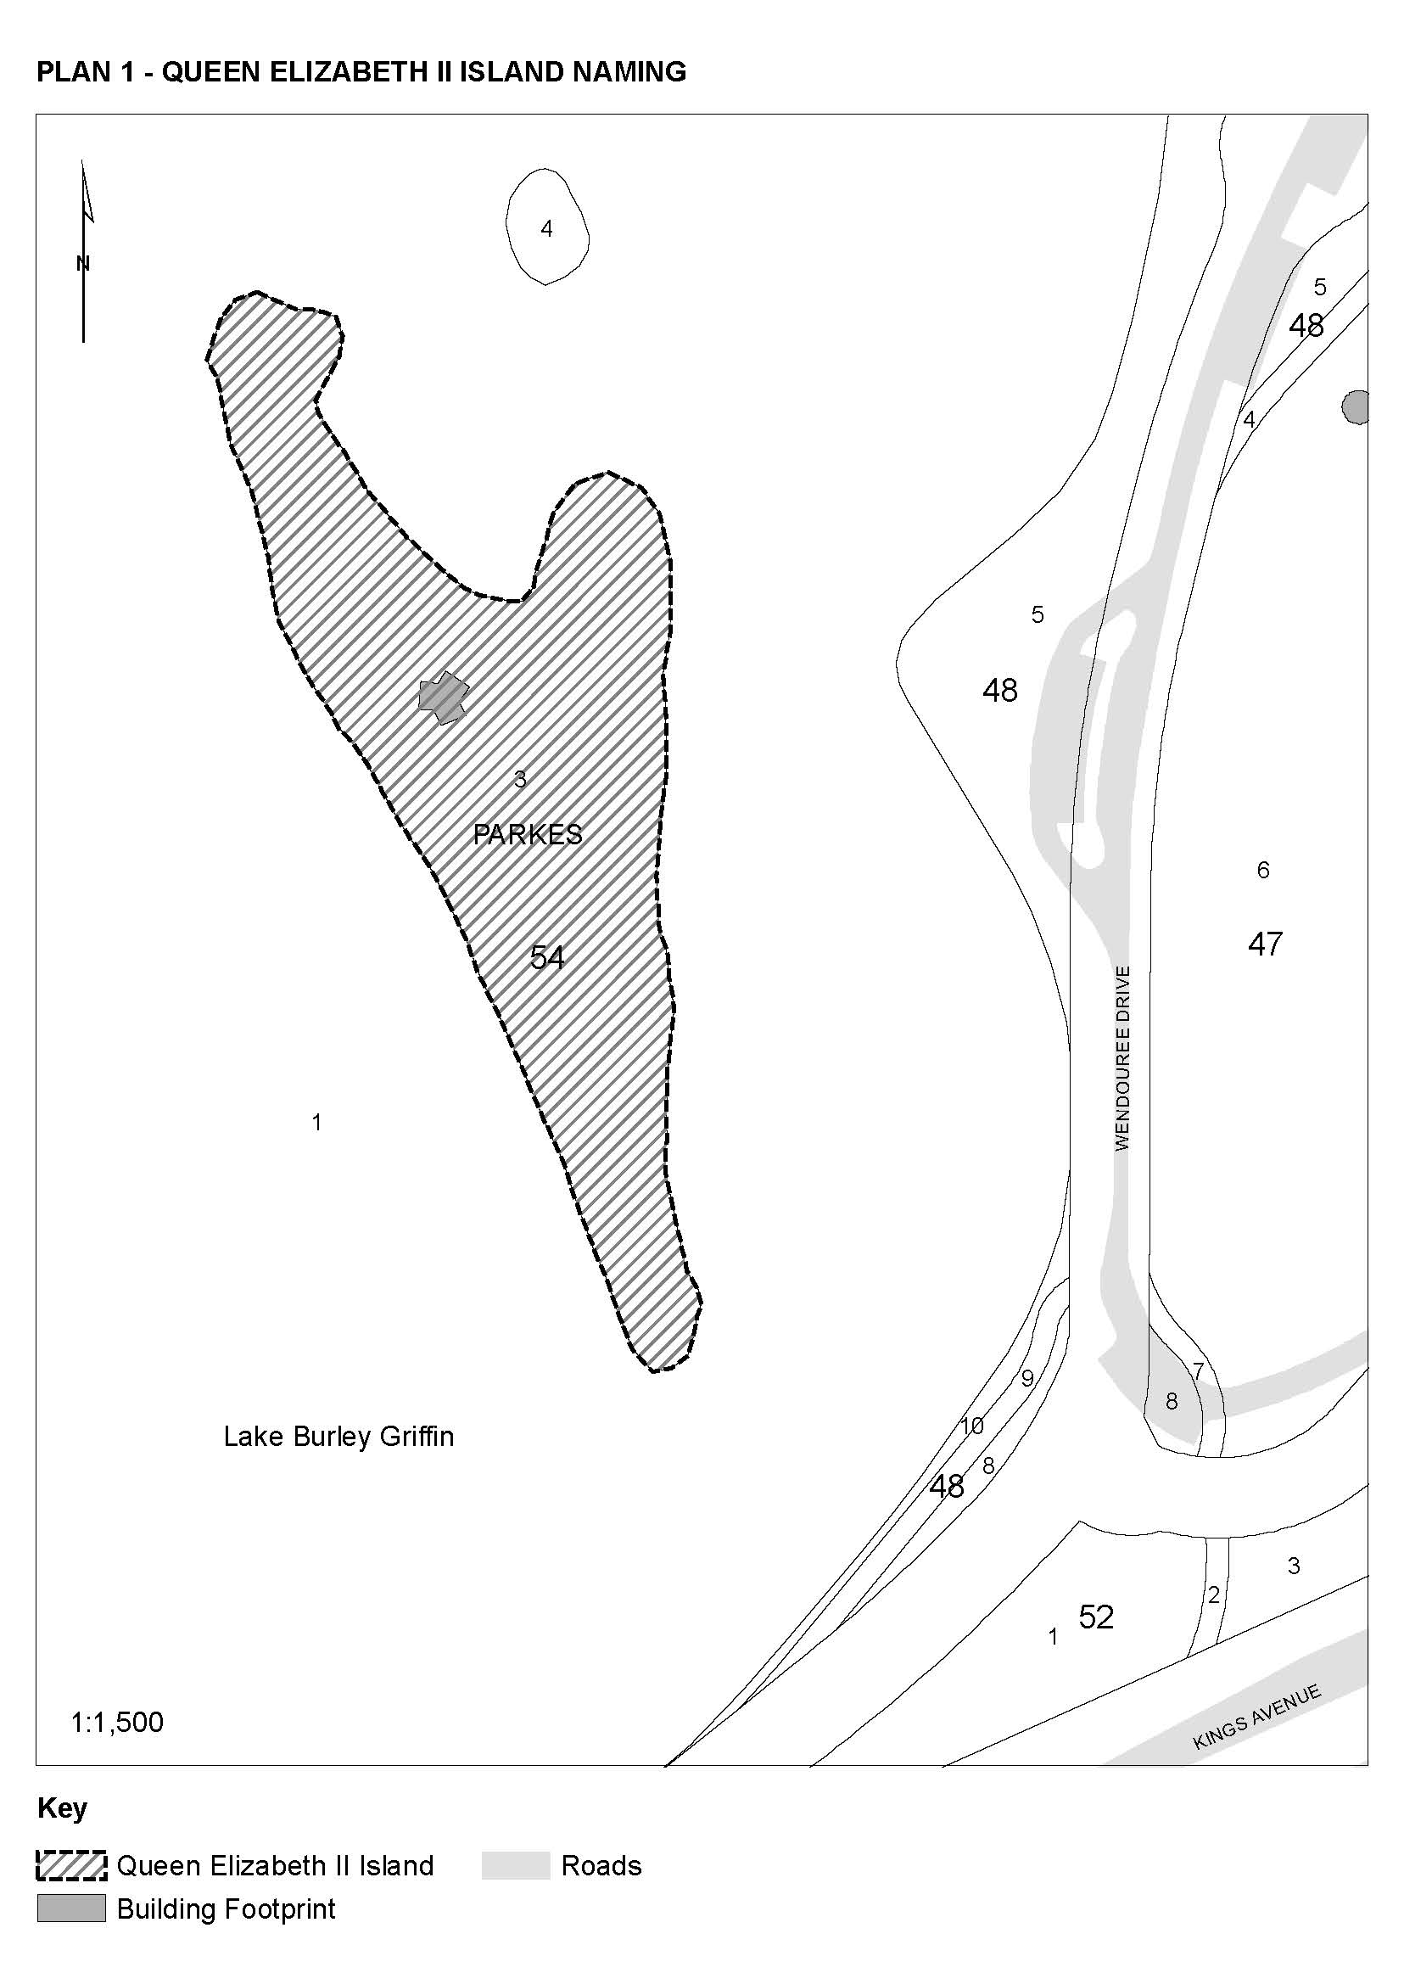

**SCHEDULE**

|  |  |  |
| --- | --- | --- |
| NAME | ORIGIN | SIGNIFICANCE |
| QUEEN ELIZABETH II ISLAND | Her Majesty Queen Elizabeth II | On 6 February 1952, King George VI died following a prolonged illness. Princess Elizabeth immediately acceded to the throne, becoming Queen Elizabeth II and taking on all of the responsibilities which came with her new title. The Coronation took place in Westminster Abbey on 2 June 1953.  In 2022, Her Majesty Queen Elizabeth II became the first Australian Monarch to celebrate a Platinum Jubilee after 70 years of dedicated service to Australia and the Commonwealth.  The naming of Queen Elizabeth II Island marks the Monarch’s Platinum Jubilee. |
|  |  |  |
|  |  |  |